Home Learning Activities Class P1 8.6.20
Maths (3 days)  https://www.bbc.co.uk/bitesize/articles/zbkdjhv  This is a link to a lesson on dividing a 2 digit number by a 1 digit number.  There are three activities so I would suggest spending three days on this- one worksheet per day- it would probably be helpful if, each day, you re-watch the video explanations  . |  |  | Maths  Visit Maths Workout, Maths Whizz or Maths Warm Up and do 1 hour of activities.  (same as last week) | Maths  Find as many different ways as you can to make 160.
English (3 days of work)  https://www.bbc.co.uk/bitesize/articles/zhqr47h  This is a link to a lesson on whether statements are true or false. Singer Ashley Roberts is reading an extract from a book called ‘Cake’.  There are three activities to do, so, like with the maths, I would aim to complete one of these activities each day for three days. |  |  | English  Keep a daily diary of your time at home. What did you do today?  (continue from last week- this is an ongoing task) | English  Read some of your book  (continue from last week- ongoing task)
PSHE  https://www.bbc.co.uk/bitesize/clips/z87d7ty  Video link to ways of dealing with anger.  Watch the video and then make a mind map of all the things that make you angry sometimes | PSHE  Think about what you did yesterday- this time can you design a poster that has ideas for things you could do to calm down when you are feeling angry | PSHE  https://www.bbc.co.uk/bitesize/clips/zxn6n39  Sticking with the anger theme. This video has children talking about different levels of anger.  Could you make a chart of things that make you just a little angry all the way up to things that make you furious! | PSHE  Telephone/facetime a friend and have a chat.  (keep as a weekly task) | PSHE  Play a game with someone in your house.  (ongoing task)
PE  https://www.youtube.com/watch?v=dhCM0C6GnrY  Follow this You Tube link for an aerobics style workout session | PE  https://www.youtube.com/watch?v=5if4cjO5nxo  This is a slightly different cardio workout that the whole family could try! | PE  How many of something can you do?  For example, how many keepy ups can you do with a football, how many bounces on a trampoline can you do in a row before getting tired? How many times can you thrown or bounce a ball without dropping it?  *KEEP THIS ACTIVITY FROM LAST WEEK- CAN YOU IMPROVE ON YOUR TOTAL?* | PE  Do a circuit – 20 star jumps, 10 press ups, 20 tuck jumps, 30 second wall sit. Repeat 3 times.  Keep this routine from last time BUT- can you add an extra 10 reps to each exercise?  Or, if you follow a physio programme, do some of the moves from it. | PE  Lift some weights. Use real ones if you have them or if not, use tins! Do exercises you have learned!  Continue from last week- can you do more repetitions than last week?
ART  https://www.twinkl.co.uk/resource/t-l-52275-step-by-step-drawing-jungle-animals-activity-sheets  this is really fun- it is a step-by-step guide to drawing jungle animals! | Geography  Last week’s task was to think about a holiday that you had really enjoyed. This week I would like you to create a postcard that shows a picture of the place. On the back can you create a short written description of what it’s like there? | History  https://www.bbc.co.uk/bitesize/articles/z7t72sg  Link to 2 interesting videos about prehistoric Britain. Watch the videos then why not try some of the activities? | SCIENCE  Giraffes!  Can you find out as many facts as you can about these amazing creatures!  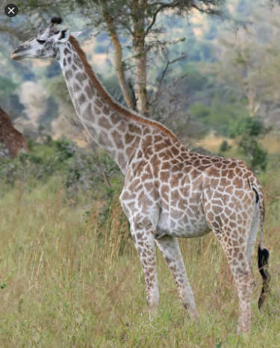 | COMPUTING  Using e-safety rules, stay in touch and chat to your friends for an hour or two each day.  Continue from last week- it is important to maintain good relationships with friends.

****Grown-ups- please remember, do not put yourselves under lots of pressure to try and complete everything on this sheet. Do what you feel you can. If there is one particular area of interest, then do more on that and less on the other bits. I know how busy you all are in these strange times! Stay safe!****

