
Home Learning Activities
Class: P4 Week: 14 Week Beg: 29.6.20

Maths  Answer these sums, using a number line or counters to help:  5+2=  8+1=  3+2=  6+3=  2+7= | Maths  Answer these sums, using a number line or counters to help:  10-8=  3-1=  5-3=  8-4=  9-5= | Maths  Find 10 blue objects in your house and write them down in a list. | Maths  Find 10 green objects in your house and write them down in a list. | Maths  Find 10 red objects in your house and write them down in a list.
English  Tell an adult or write down what you did at the weekend. You could record it on video and put it on EfL! | English  Read a story with an adult and then answer questions about it, such as “how was that character feeling?” | English  Write a list of your favourite films. | Handwriting  Practice writing the letter ‘b’ on a line. | English  Complete 1/2 pages of the English work in your learning pack.
Fine Motor Skills  Use Lego or building blocks to make a house. | Fine Motor Skills  If you have paper clips, then make a chain using them. Can you make the chain 10 paper clips long? | Fine Motor Skills  Draw some squiggly lines on a piece of paper, and then use scissors to cut along those lines. | Fine Motor Skills  Make a drink yourself, with adult supervision and a little support if needed. | Fine Motor Skills  Colour in a picture.
PE/Gross Motor Skills  How many star jumps can you do in 30 seconds? Have another go and try to beat it. | Sensory  Put some paint in a zip lock bag and draw patterns using your finger.  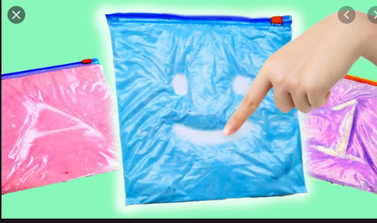 | Sensory  Have an adult give you a hand massage with some hand lotion. Maybe you could give them one too? | PE/Gross Motor skills  Watch an episode of Cosmic Kids on Youtube and have a go! | PE/Gross Motor Skills  Jog on the spot for 30 seconds, have a 30 second rest then repeat! See how many times you can do it.
Music  Learn the dance to a song, e.g. Steps 5,6,7,8! | Computing  Play some educational games on one of the websites that school have recommended, e.g Purple Mash | PSHE  Help an adult to cook or bake. | Geography  Find some flag colouring on Google or have a go at drawing different flags yourself. | Science  See what sinks and floats in a tub of water.

