
Home Learning Activities
Maths Overview: This week, we will be exploring Handling Data
Definition and examples – Handling Data - Data handling means gathering and recording information and then presenting it in a way that is meaningful to others.
Useful websites- https://uk.splashlearn.com/class/mrs-mac-class-6/grades/first-grade/curriculum
https://www.topmarks.co.uk/maths-games/5-7-years/data-handling
https://www.bbc.co.uk/bitesize/topics/zyq7hyc (Key Sage 1) https://www.bbc.co.uk/bitesize/topics/z7rcwmn/resources/1 (Key Stage 2)

Monday | Tuesday | Wednesday | Thursday | Friday
Maths  Watch the clip…  https://www.bbc.co.uk/bitesize/clips/zjbcd2p  Practice making tally marks at home. You can collect data on just about anything!  What is your favourite ice-cream flavour? We can collect all the data on Monday during our zoom meeting and find out what our favourite ice-cream is and you can fill in the chart at home, later on in the day.  Have a go at some of these games…  https://www.softschools.com/math/data_analysis/tally_chart/  http://www.snappymaths.com/other/handlingdata/barcharts/interactive/talliesimm/talliesimm.htm | Maths  Watch the clip…  https://www.bbc.co.uk/bitesize/topics/zg6tyrd/articles/zgg9pbk  Have a go at playing a game of Rock, Paper, Scissors at home with somebody.  Play a round of this game 10 times and each time record a tally of who wins (just like the tally chart in the video for Pete the Sneak!).  Have a go at filling in the data chart at the bottom of the video clip! | Maths  Watch the clip…  https://www.bbc.co.uk/bitesize/clips/z4nyr82  Look at the data from Monday and the tally chart we created on that day. Use this tally chart to create a block graph, just like the children did in the video clip. You can draw the ice-creams on post-it notes or cut up pieces of paper with a grown-up.  Take a photograph of your graph and record on Evidence for Learning. | Maths  Check out Espresso,  For KS1, all of the videos and activities on handling data are under the title – Statistics.  https://central.espresso.co.uk/espresso/primary_uk/subject/module/frontscreen/item883307/grade1/index.html?source=subject-Maths-KS1-Maths-Resource%20types  For KS2, all of the videos and activities on handling data are under the title – Real-life Maths.  https://central.espresso.co.uk/espresso/modules/resource_box/real_life_maths/page_1.html?source=subject-Maths-KS2-Maths-Resource%20types  Username: student7070  Password: green3 | Maths  Write a set of questions for your tally chart or your graph.  E.g. Which ice-cream has the most votes?  Which ice-cream is the most popular.  Note: Drawing pictures of the problem will help with understanding
English Overview: This week, we are continuing with our topic on Stories about Imaginary Worlds.
Definition and examples – An imaginary world is a place that only exists in your mind or in a story or a film. It is not a real place like a supermarket or a forest, but one that can be as magical or as fantastical as possible.
Useful websites - https://vimeo.com/36088583
https://www.bbc.co.uk/bitesize/topics/z6vv4wx/articles/z24rxfr
Recommended Reading - Beyond the Pond – by Joseph Kuefler. Pool – by JiHyeon Lee. This is Sadie – by Sara O’Leary. Journey and Quest – by Aaron Becker. Where the Wild Things are – by Maurice Sendak
Monday | Tuesday | Wednesday | Thursday | Friday
English  Reading/writing  Watch the video…  https://www.youtube.com/watch?v=TnwbKlnf34E  Listen to the story, ‘Beyond the Pond’  This week, is the week we write our final piece of work linked to our topic. This is our ‘Show What you know’ task!  Begin to write a plan for your final piece of writing.  Fill in the plan below. | English  Writing  Watch the clip…  On Evidence for learning, watch my video explaining how to use your plan to write your setting description. You can use any of the story beginnings below to begin your story and then…away you go!  We would love to see your stories!  Either pop on Evidence for Learning or save in your home-school books. | English  Speaking and Listening  Give me Five!  Think of different categories (E.g. vegetables, fruit, animals, toys etc).  Children need to say 5 things in that category…  apple  banana  grapes  orange  pear | English  Handwriting  Check out the videos on Espresso in the handwriting section. Look at the videos showing how to write curly caterpillar letters – c, a, d, o, s, g, q, e, f  Have a practice yourself. | English  SPG  Do a look, cover and write with the following words…  chip  chin  chat  check  chick  What was your score? Can you think of any more ‘ch’ words?
PSHE Overview: This week we will explore a poem by a Manchester poet called Matt Goodfellow. His work ties the topic together nicely and gives us a fun project to do together. The poem is from his book, ‘The Same Inside’

Useful websites - https://thelinkingnetwork.org.uk/resource/choose-matt-goodfellow/
https://www.mentallyhealthyschools.org.uk/resources?gclid=EAIaIQobChMI7cH8-eaE7gIVrIBQBh37NwCGEAAYAiAAEgIy9fD_BwE
https://www.mind.org.uk/get-involved/mental-health-awareness-week/?gclid=EAIaIQobChMInczQqbK87gIVTe3tCh1_6wDWEAAYBCAAEgJQ5vD_BwE
Monday | Tuesday | Wednesday | Thursday | Friday
PSHE  This week, we will be exploring the poem Choices, by Matt Goodfellow.  Listen to his poem and discuss with an adult.  https://thelinkingnetwork.org.uk/resource/choose-matt-goodfellow/ | PSHE  Make a list of the words in the poem and put them into a table. | PSHE  Talk to a grown-up and decide which of these words are bitter and which are better? | PSHE  Talk to people in your home and decide which better words you are going to use today. | PSHE  Choose your favourite better word and create a colourful word-art poster for this word.  Some Examples of art you could create with your word…    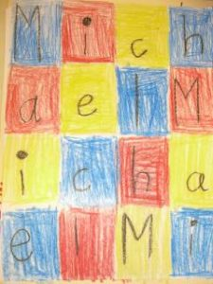  
  Bitter words | Better Words
  love thank you
  steal hate share
  smile hope destroy
  listen ignore
  support help
  love thank you
  share hope
  smile listen
  support help
PE  Check out Cosmic Kids  Jamie is back again this week, with her cosmic yoga moves. Try a different one each day.  https://www.youtube.com/watch?v=dnwHDN6Dw7Q | PE  Check out Cosmic Kids  Jamie is back again this week, with her cosmic yoga moves. Try a different one each day.  https://www.youtube.com/watch?v=rnlDBKD2S78 | PE  Check out Cosmic Kids  Jamie is back again this week, with her cosmic yoga moves. Try a different one each day.  https://www.youtube.com/watch?v=j_3weVPH0-U | PE  Check out Cosmic Kids  Jamie is back again this week, with her cosmic yoga moves. Try a different one each day.  https://www.youtube.com/watch?v=LhYtcadR9nw | PE  Check out Cosmic Kids  Jamie is back again this week, with her cosmic yoga moves. Try a different one each day.  https://www.youtube.com/watch?v=xhWDiQRrC1Y
Design Technology  Our topic this term is Playgrounds  Try and make a swing this week.  You could use the left-over straws from the history project!  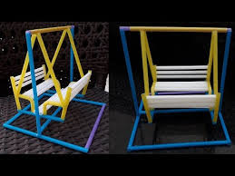  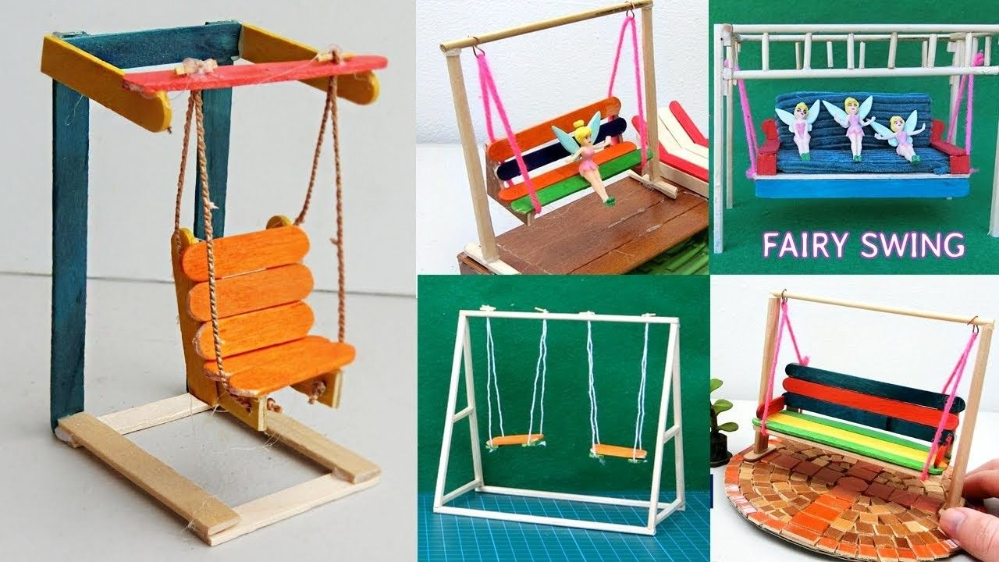 | History  Our topic is the history of transport.  Hopefully, you will have your packs now to make your model. Have fun doing this. Check out our models on Evidence for learning for some ideas.  Take a picture of yours to share on Evidence for learning.  https://www.theschoolrun.com/homework-help/history-of-flight  https://www.youtube.com/watch?v=UvZd6CGvIX0 | Food Technology  This is a fun challenge for you. Thinking about our rock topic in science, have a go at making a rock themed snack!  Check out these ideas for inspiration!  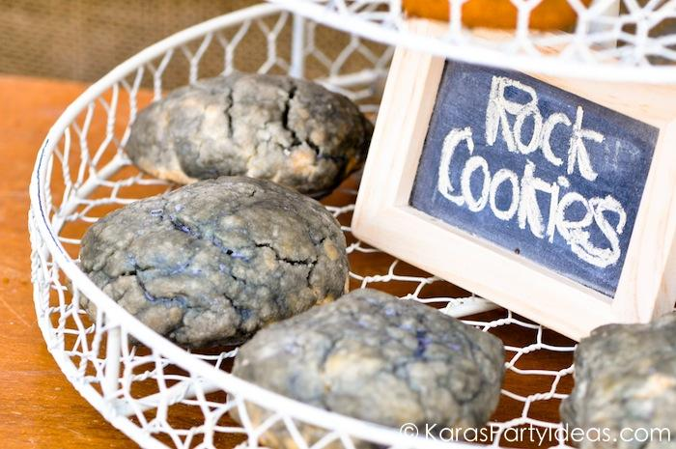  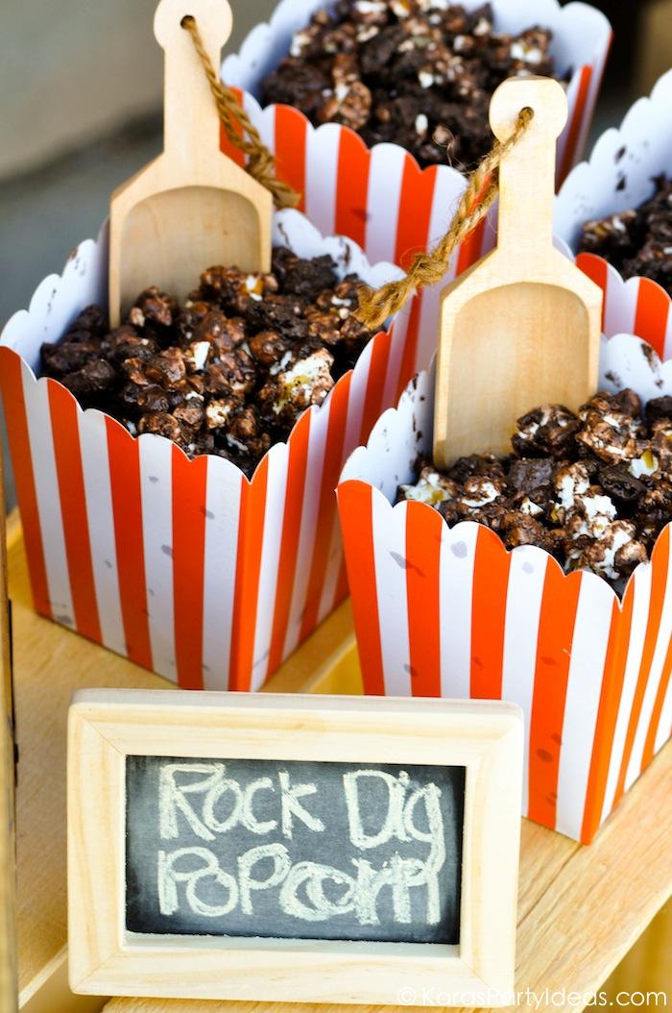  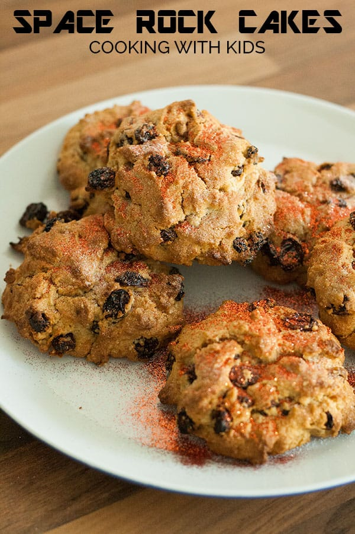  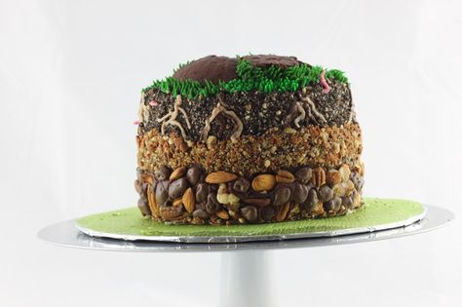  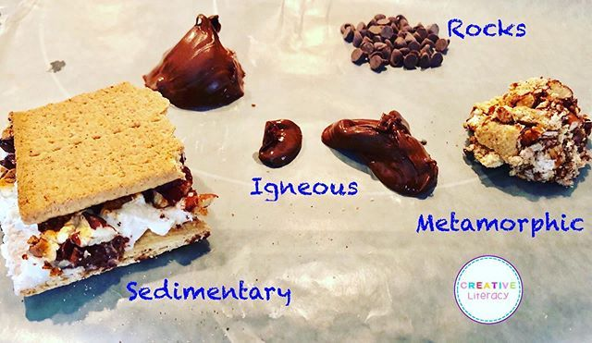 | SCIENCE  Our topic this half-term is Rocks and Where do rocks Come From?  This week we are exploring metamorphic rocks.  Find out how metamorphic rocks are formed and the rock cycle…  https://www.coolkidfacts.com/metamorphic-rock-facts/  https://www.sciencekids.co.nz/sciencefacts/earth/metamorphicrocks.html  Watch the clip…  https://www.youtube.com/watch?v=Vp_S3BDiR-I  Have a go at filling in the words in the rock cycle diagram below. | COMPUTING  On Espresso, have a go over the next few weeks at completing your level 1 computing licence.  https://central.espresso.co.uk/espresso/modules/ey_computer_driving/index.html

Data Handling. Monday
LO: To collect data using tally marks.
Ice-cream flavour | Tally
Strawberry
Chocolate
Vanilla
Mint Choc-chip

LO: To write a plan for your imaginary story setting.

My setting is: | Sounds:
Smells: | Sights:
Similes: | Adjectives:
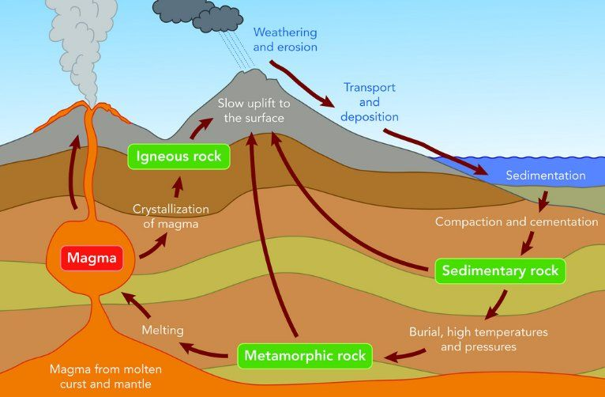
1.
3.
2.
Answers:

1. Igneous rocks
2. Sedimentary rocks
3. Metamorphic rocks

