LO - To compare ideas and perspectives of both main characters.

Similarities and differences

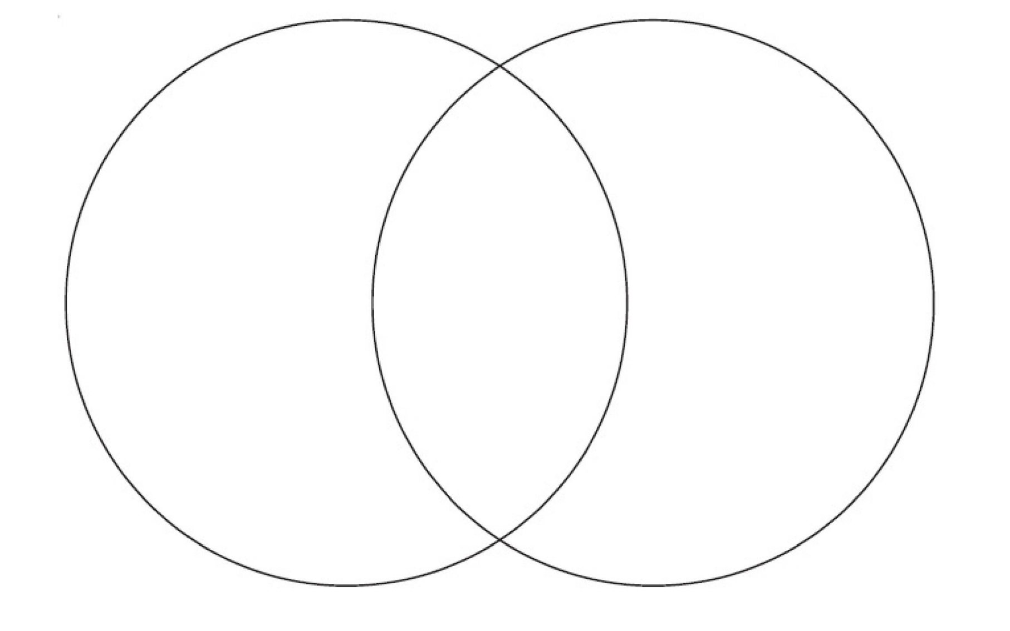
Think about the snail and Phileas Fogg. What do they have in common? What is different about them? Complete the Venn diagram to show this information.

