
Home Learning Activities Topic: Under the Sea
English  Sharing a shell: Julia Donaldson (Pamela Leach on Youtube))  Collect photographs of family members. Draw a large shell and place photos in it. Can you name or find people who are a part of your shell? | English  Sharing a shell: Julia Donaldson (Pamela Leach on Youtube)) Use the shells with trace patterns I sent home to practise pencil coordination. Use the picture of my grip which I sent in the first pack, to encourage correct use of the pencil. | Maths  Days of the week song – Baby Bum songs on Youtube  Begin to look at the day names and the weather symbols in the pack I sent home. | SCERTS / Maths  Cooperate with a partner  Set up a little shop, put prices on tins of food, fruit and vegetables up to 10p. Get pupils to buy the toys using 1p coins. | Maths  Days of the week song – Baby Bum songs on Youtube  Use the ‘Today is’ chart I have sent home and every day put the correct day name and weather symbol
SCERTS / PSED / Communication  Fill plastic bottles with water and add water. Add glitter, sequins etc. Seal the lid with strong glue (best done by mum/dad) and use the sensory bottles by tipping backwards and forwards like the sea (see picture below). | Phonics  Making sounds with our bodies: show me how to make different sounds use my body e.g. clicking fingers, slapping leg gently, rubbing hands together etc. See how many sounds I can make. | Phonics  Write the letters of my name on pebbles/shells or bottle tops – whatever you have. Hide in sand, let me find them a& then get me to order the letters to make my name (write it for me to copy if I struggle) | Phonics/Reading: Share a book  See if pupils can find small details in pictures.  If possible you can extend this by asking pupils to find an object beginning with a certain sound. | SCERTS / PSED  Cooperate with a partner  Help to make lunch, let me do as much as I can – I do quite a lot for myself in school – including the tidying away and washing up!
SCERTS / PD  Practise washing and drying your own hands and face. | SCERTS / PD  Using bubbles in the garden – get pupils to hold the bubble stick and move like waves in the sea. I have included a recipe for bubbles below, in case you do not have any, and you can make a stick with a straw and pipe cleaner, picture below. | SCERTS / PD  You may have a sensory parachute at home, if not use a small, light sheet or throw. Hold the sides and move it up and down like waves. Add balloons or soft balls and move them around like the foam bubbles on waves. Try to keep the balloons/balls on the sheet. | SCERTS / PD  Draw a large sea snail including the spiral on his shell. Get pupils to use the index finger and thumb to pick up cheerios / pompoms or something similar, and lay them along the spiral – this is good practise for fine motor skills. | SCERTS / PD  Use different mark making tools to draw spiral shapes on paper. If pupils struggle, you can do some yourself to start with and get pupils to trace with their fingers and then crayons.
SCERTS / Expressive arts  Cut circles of card, size of a dinner plate. Get pupils to decorate them and then draw a spiral which pupils can add glue to and sand, add a body and make a sea snail (see picture below). | SCERTS / Knowledge and Understanding of the World.  Use playdough to roll sausages – one to be the snail’s body and another which can then be rolled into a shell shape. Extend: Make more snails of different sizes and order from big to small / count them / match colours etc. | Computing  https://www.helpkidzlearn.com/ Log on and use the number songs  (you received the passwords in a parent mail) | SCERTS / Expressive arts  Let pupils use glue and sand to make pictures. PVA glue is best for this and it is a good idea to put newspaper down first to protect surfaces. | Computing  https://www.helpkidzlearn.com/ Log on and use the number songs  (you received the passwords in a parent mail)
Class: 3N Week Beg: 01.02.21 *Follow the sensory activities ideas available on the school website, particularly at the start of each morning and afternoon sessions. Please load any work/photos onto Tapestry.
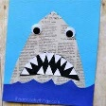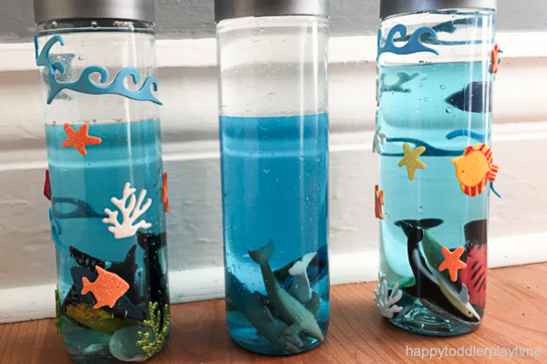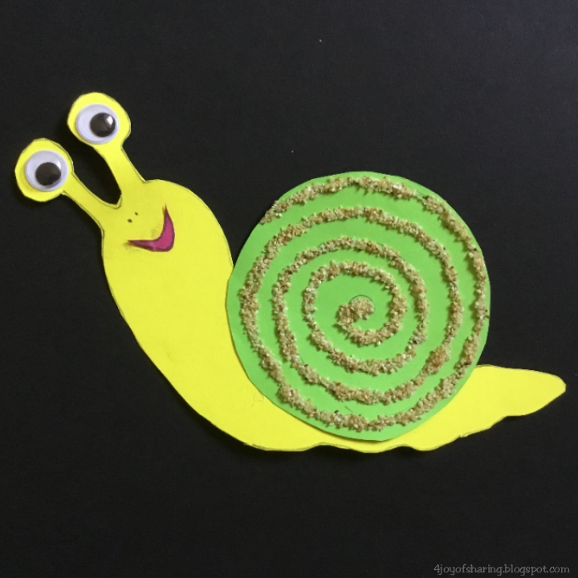

How to Make Homemade Bubbles
INGREDIENTS
- 4 cups warm water
- 1/2 cup sugar
- 1/2 cup washing up liquid
INSTRUCTIONS
- Combine the sugar and water - Whisk the sugar into the warm water until the sugar dissolves.
- Whisk in the soap - Add the dish soap and whisk to combine.
- Let sit -This step is only if you have some patience or think to make the solution ahead of time. Letting the homemade bubbles sit for a couple of hours or even overnight helps them work a bit better, but is not strictly necessary
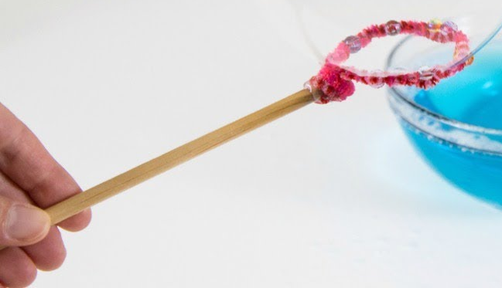 an easy bubble stick

