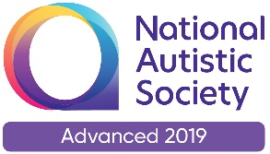 | 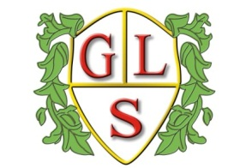 | Paul King  Headteacher  Joanne Mullineux  Deputy Headteacher

Dear Parent/Carer,

As of September 2020 parts of our current PSHE curriculum is to become statutory in all schools in England. The aim of the new curriculum to help children to grow up healthy, happy, safe and able to manage the challenges and opportunities of modern Britain. Therefore alongside elements that we already cover it will now be compulsory for children to cover specific areas of health, relationship and sex education. As a school we have the flexibility to deliver the statutory content in a way that is age and developmentally appropriate as well as being sensitive to the needs and religious backgrounds of all pupils. Below are a list of compulsory elements based on Primary and Secondary aged children.

Primary and Secondary aged children will cover:
Health education including-
Mental Wellbeing
Internet safety
Fitness
Health and Prevention (e.g. personal hygiene)
Healthy Eating
Drugs, Alcohol and Tobacco
Basic First Aid
Changing adolescent body (Puberty)

Then Primary aged children will cover:
Relationships education including-
Families and people who care for me
Caring friendships
Respectful relationships
Online relationships
Being safe

Secondary aged children will cover:
Relationships and sex education including-
Families
Respectful relationships
Online and media
Being safe
Intimate and sexual relationships including sexual health
The Law.

There is further information via the link below:
https://www.gov.uk/government/publications/relationships-sex-and-health-education-guides-for-schools

Any questions or queries about this please do not hesitate to contact myself or Mr King and we will be happy to talk further.

Regards,

Sarah Van Rooy

PSHE Co-ordinator

