P2 Autumn Term 2020

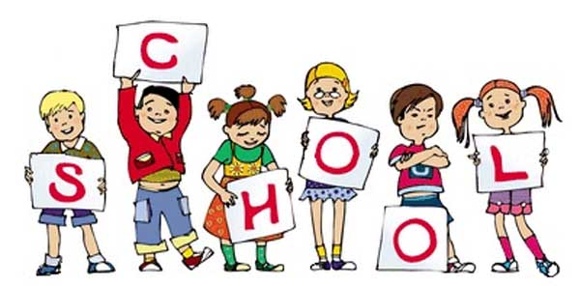

P2 staff Ms K.White

Mrs K.Dickson

Mrs L. Stewart

Ms J.Farrington

**Topics**

**Autumn 1**

Number: Addition and subtraction.

Place value.

**Autumn 2**

Geometry: shape 2D and 3D shape. Measurement – length and mass. Number – multiplication and division.

**Topics**

Myths and legends. Letter writing.

Spelling and Phonics, Guided Reading, Guided Writing, Handwriting.

Speech and language work.

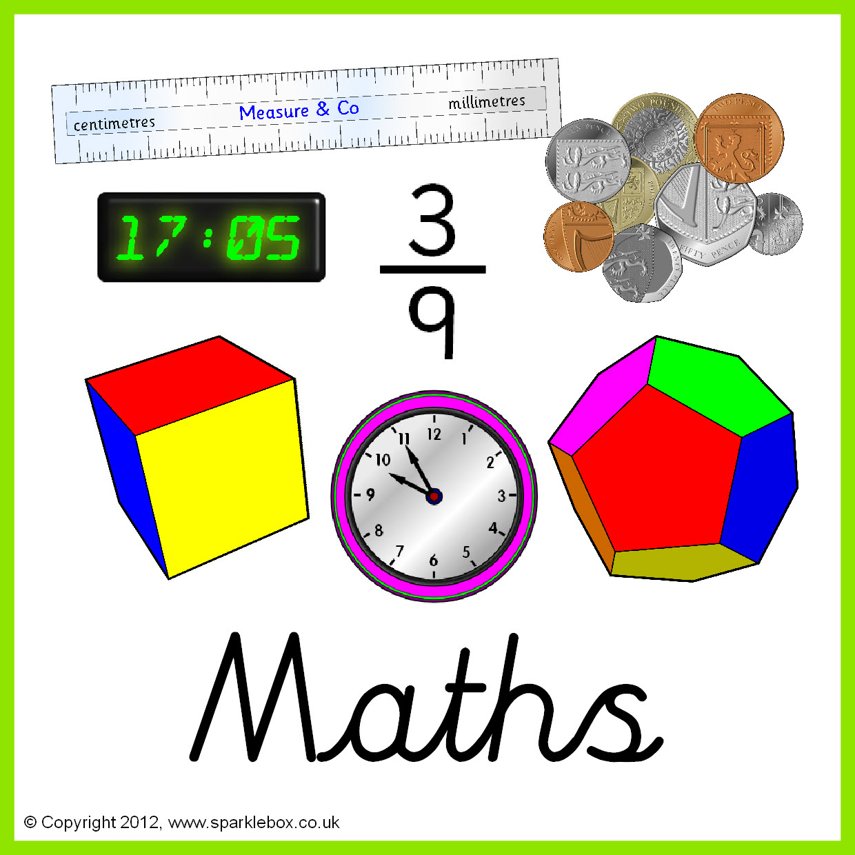

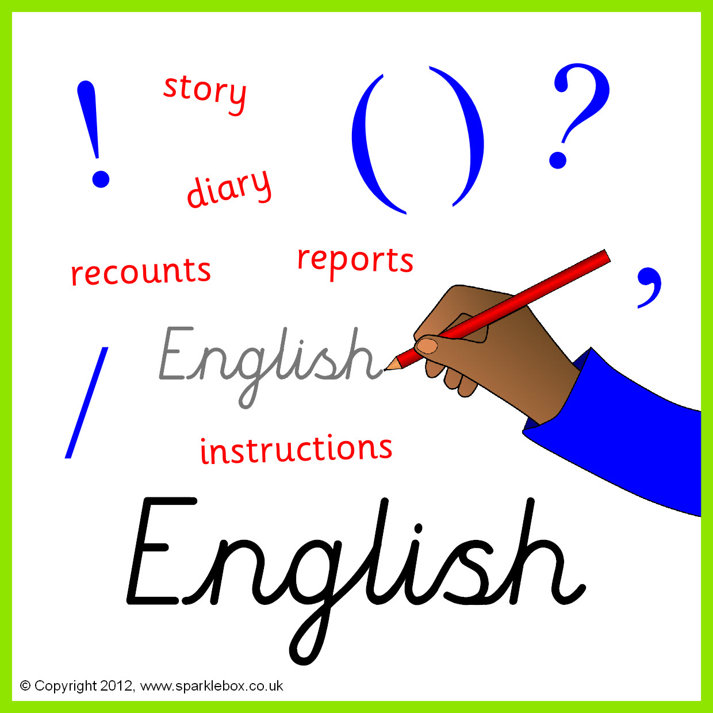

**Topics -** Taught by D. Taylor

E Safety

Algorithms & Programming.

**Topics**

Solids, liquids and gases.

Reproduction of plants and animals.

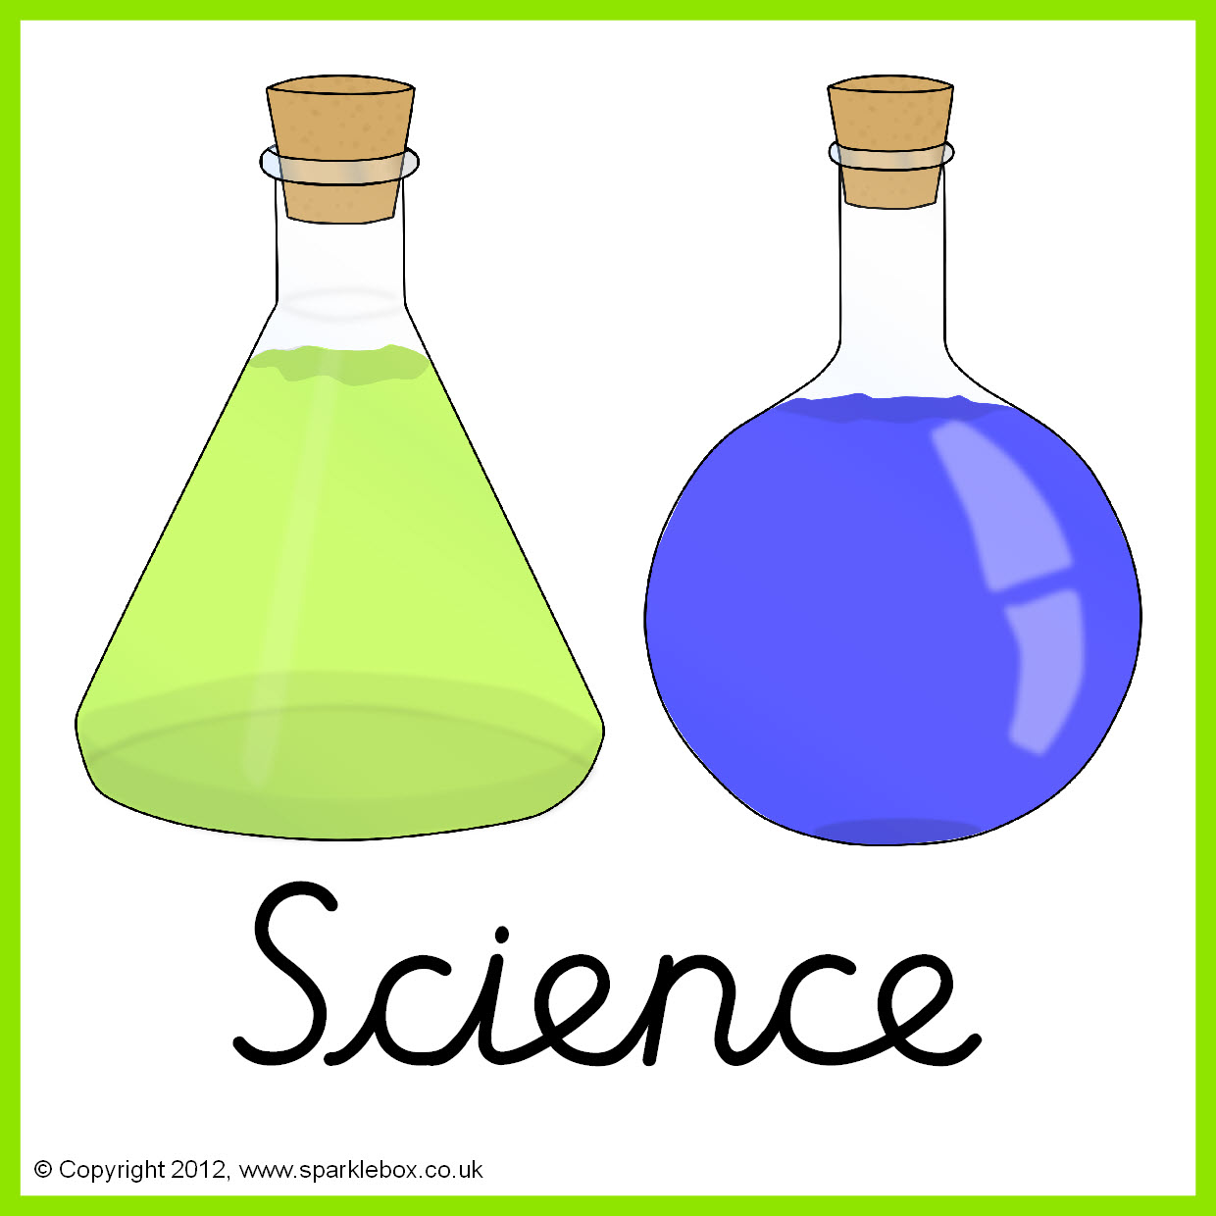



**Topics** – Taught by L.Fernyhough

Introduction to the formal elements.

Masquerade masks.

**Topics** - Taught by L. Fernyhough

North and south Hemisphere.

Europe

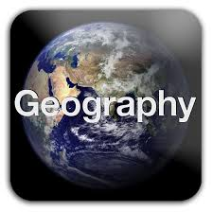



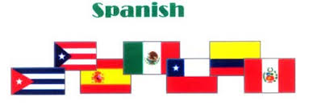

**Topics**

All about Spain. Spanish fiestas.

Spanish Christmas.

**Topic** -Taught by L. Fernyhough

The invasion of Roman Britain.



**Topics**

Who is my neighbour? Harvest.

Celebrations and special times. Giving and receiving.

**Topics**

Tennis and Hand ball.





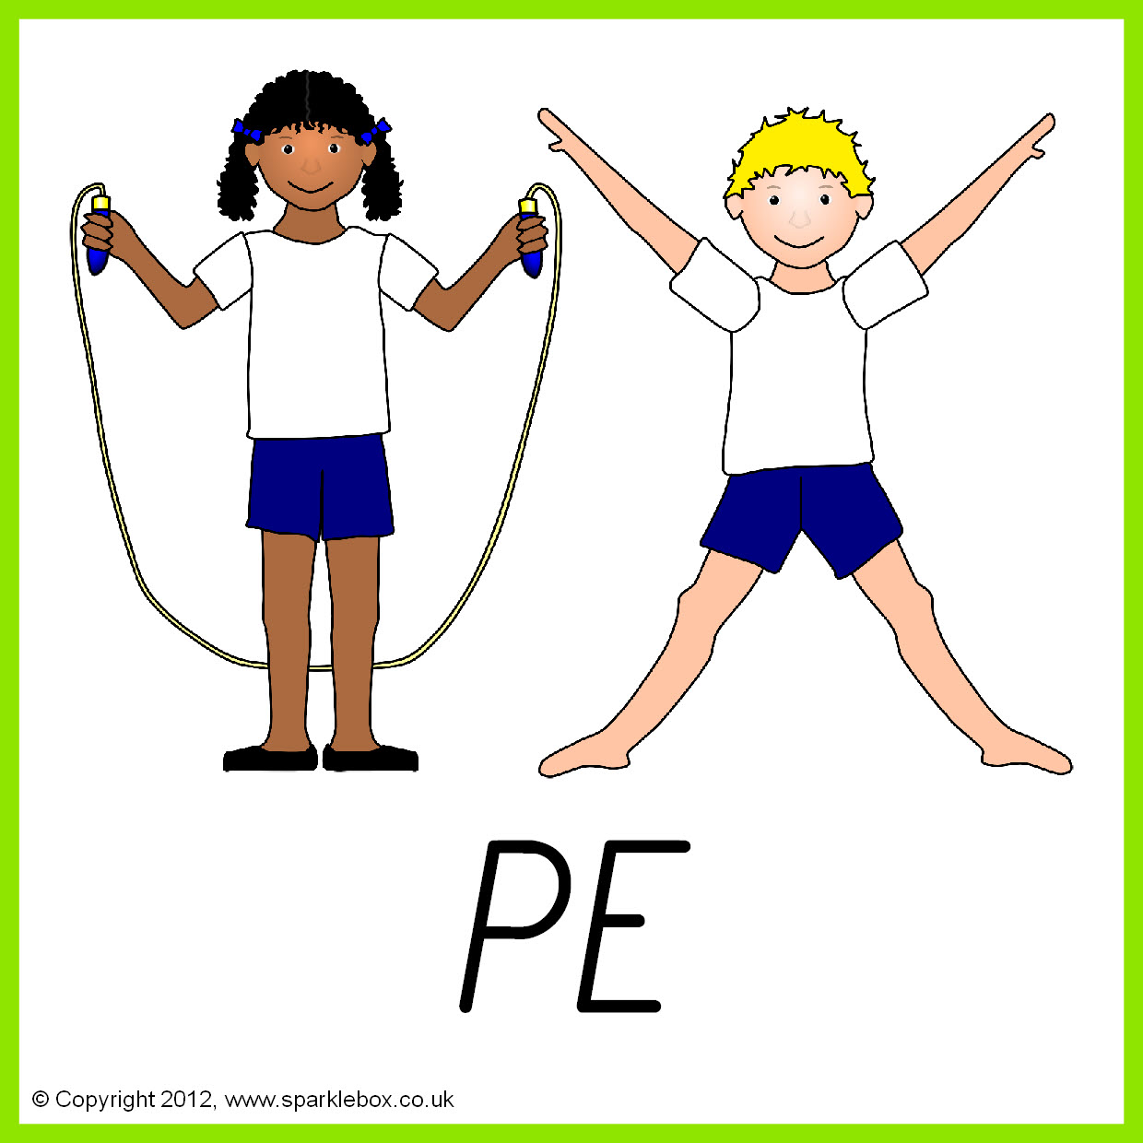

**Topics**

Famous inventors. How things work in the living room. Winter puddings.

**Topics**

Personal hygiene.

Relationships and friendships.

.

