Home Learning Activities Class P1 wb 5th October
Maths (3 days)  https://classroom.thenational.academy/subjects-by-year/year-5/subjects/maths  This link will take you to an Oak Academy series of maths lessons. These are good because they are very similar to what we have been doing in class over the last couple of weeks.  The screen will look like this: |  |  | Maths  Visit Maths Workout, Maths Whizz or Maths Warm Up and do 1 hour of activities.  (same as last week) | Maths  Find as many different ways as you can to make 1500.
English (3 days of work)  https://classroom.thenational.academy/units/the-day-the-crayons-quit-persuasive-writing-0c4a  Follow this link to a series of English lessons on persuasive writing.  It is based on ‘The Day the Crayons Quit’ which is a really funny picture book aimed at older children.  Try the first 3 or 4 lessons. The screen should look like this…  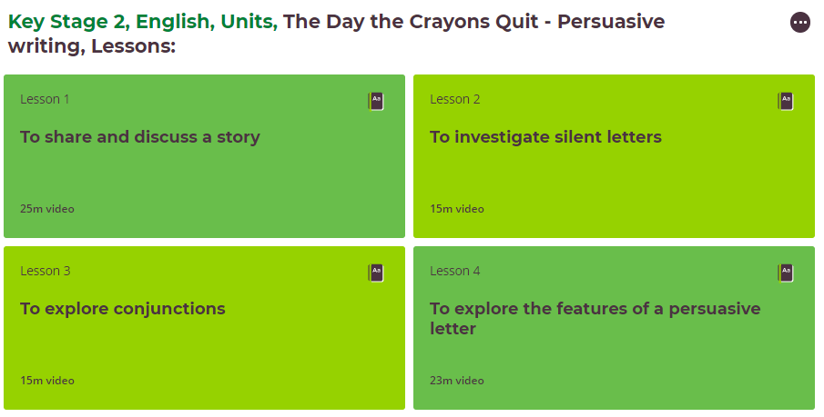 |  |  | English  Keep a daily diary of your time at home. What did you do today?  (continue from last week- this is an ongoing task) | English  Read some of your book  (continue from last week- ongoing task)
PSHE  Go on to BBC Newsround and check out the stories that have been in the news this week. There are a lot of different stories. Watch some of the videos or read some articles and spend some time researching this topic. |  |  | PSHE  Telephone/facetime a friend and have a chat.  (keep as a weekly task) | PSHE  Play a game with someone in your house.  (ongoing task)
PE  https://www.youtube.com/watch?v=2X1p0Yd6WAo  This is a link to a Joe Wicks ‘Spiderman’ workout! | PE  https://www.youtube.com/watch?v=HVdBlK3jVqw  This is another Joe Wicks superhero workout! This time featuring Batman! | PE  How many of something can you do?  For example, how many keepy ups can you do with a football, how many bounces on a trampoline can you do in a row before getting tired? How many times can you thrown or bounce a ball without dropping it?  *KEEP THIS ACTIVITY FROM LAST WEEK- CAN YOU IMPROVE ON YOUR TOTAL?* | PE  Do a circuit – 20 star jumps, 10 press ups, 20 tuck jumps, 30 second wall sit. Repeat 3 times.  Keep this routine from last time BUT- can you add an extra 10 reps to each exercise?  Or, if you follow a physio programme, do some of the moves from it. | PE  Lift some weights. Use real ones if you have them or if not, use tins! Do exercises you have learned!  Continue from last week- can you do more repetitions than last week?
ART  https://www.youtube.com/watch?v=IRp3sBQ-NFU  To fit in with what we have been learning about in art, this video will teach you how to draw a simple self portrait. | Geography  Research an African country of your choice  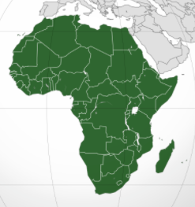 | History  Design your own Roman shield. If you have any old bits of cardboard at home you could even try making it!  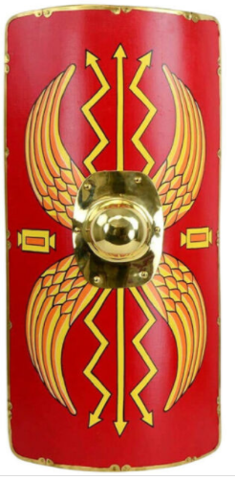 | SCIENCE  Triceratops  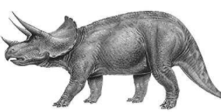  Can you find out as many facts as you can about these amazing dinosaurs! | COMPUTING  Using e-safety rules, stay in touch and chat to your friends for an hour or two each day.  Continue from last week- it is important to maintain good relationships with friends.

****Grown-ups- please remember, do not put yourselves under lots of pressure to try and complete everything on this sheet. Do what you feel you can. If there is one particular area of interest, then do more on that and less on the other bits. I know how busy you all are in these strange times! Stay safe!****

