
Home Learning Activities - https://www.loom.com/share/038bbf80f8454bd79b2125e6f139912a (copy the link and paste into chrome)
Maths Overview: This week, we will be exploring Multiplication.
Definition and examples – Multiplication is when you take one number and add it together a number of times. ... This is why multiplication is sometimes called "times". (E.g. 2 + 2 + 2 + 2 = 8 or 4 x 2 = 8)
Useful websites- https://www.splashlearn.com/math-vocabulary/multiplication/multiplication https://www.timestables.co.uk/games/
https://www.topmarks.co.uk/maths-games/7-11-years/multiplication-and-division https://www.bbc.co.uk/bitesize/topics/z36tyrd
https://www.bbc.co.uk/bitesize/topics/zqbg87h
You can make any of these activities below easier or harder by applying different multiplication tables in each activity: The 2 times table or the 12 times table!
Monday | Tuesday | Wednesday | Thursday | Friday
Maths  Watch the clip…  https://www.bbc.co.uk/bitesize/  topics/zqbg87h/articles/z3tvcj6  Practice making arrays for the 2 times table.  1 x 2 = 2  2 x 2 = 4 | Maths  Watch the clip…  https://www.bbc.co.uk/bitesize/  topics/zqbg87h/articles/zc7ygdm  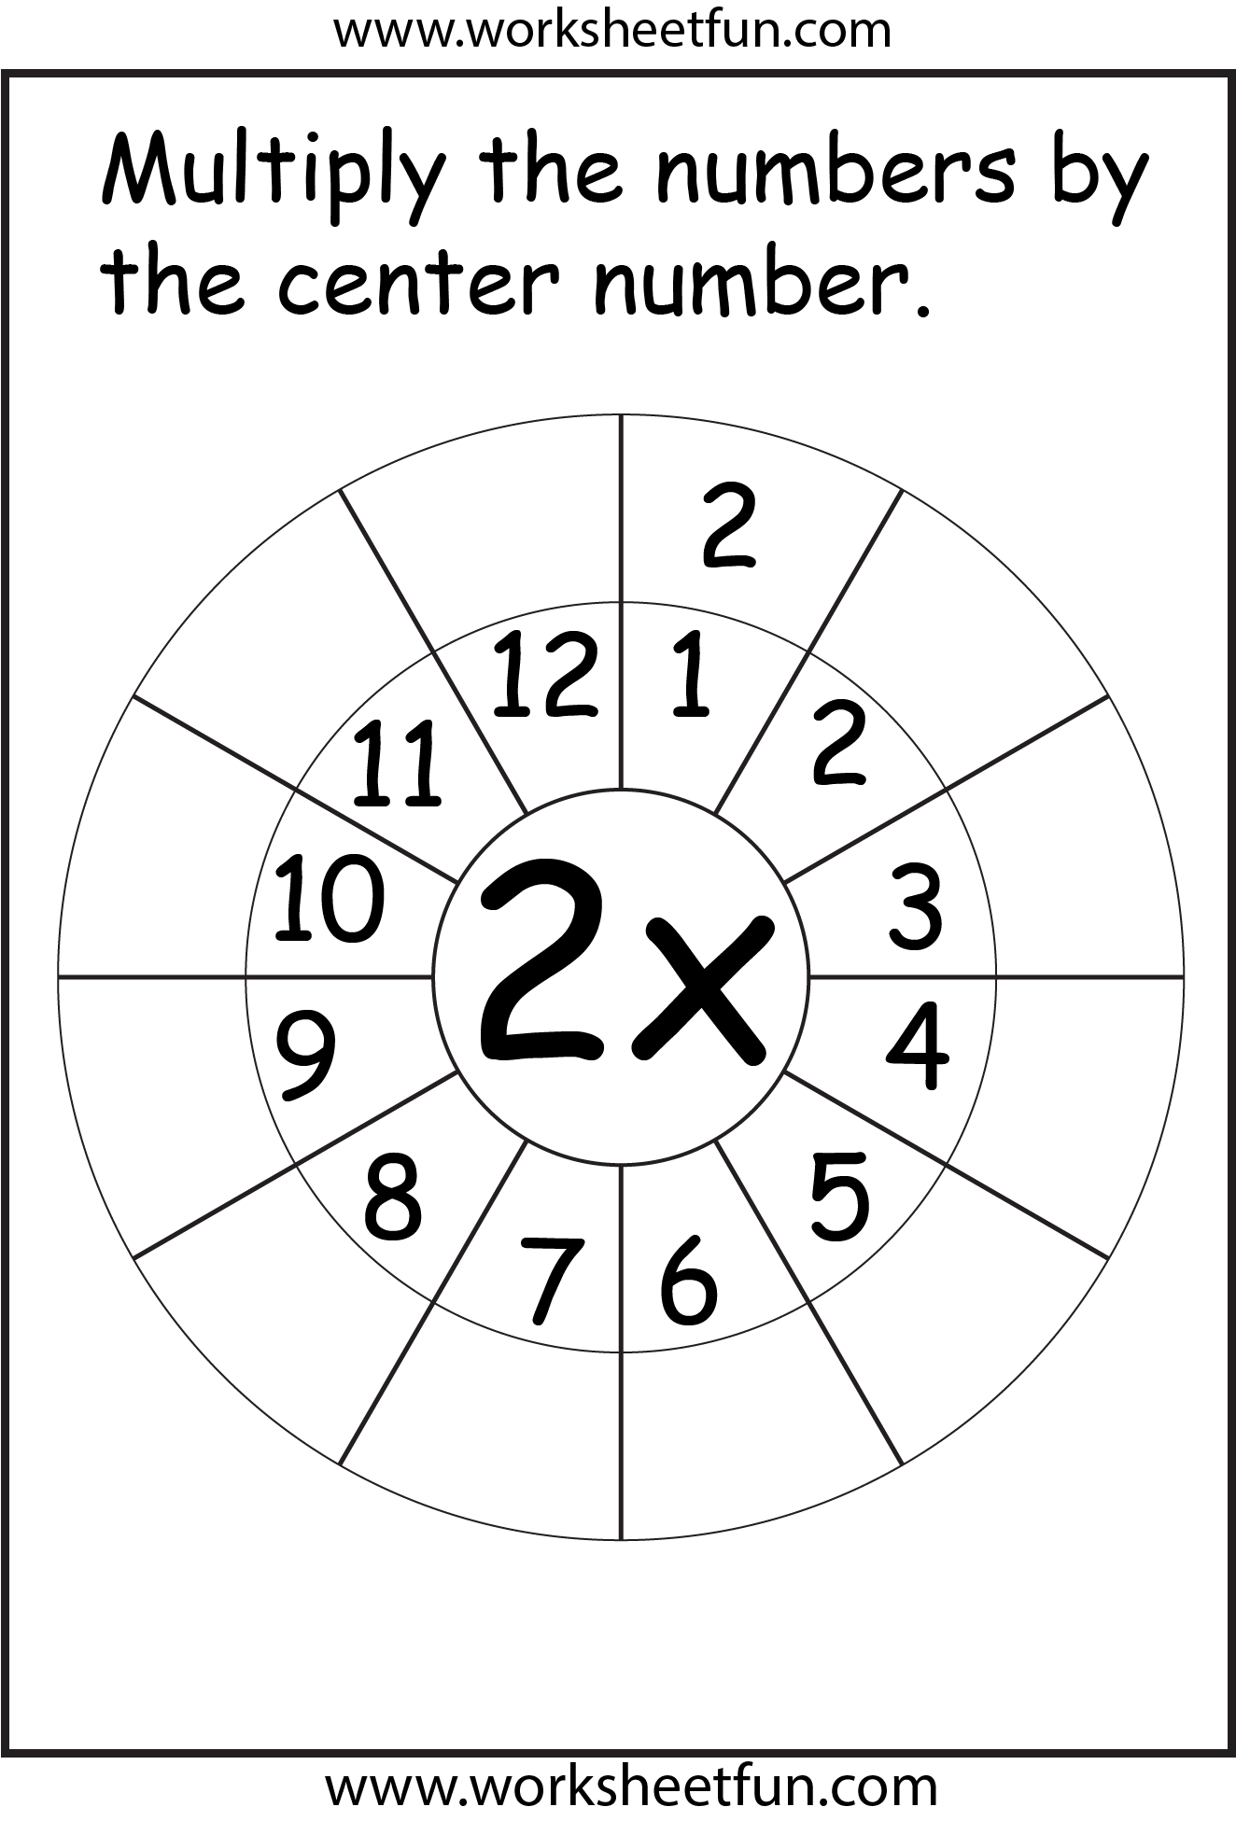  Have a go at making a multiplication wheel. You could do this for any multiplication number. | Maths  Have a go at making a fortune teller for a multiplication table. You can do this with a piece of paper cut into a square shape.  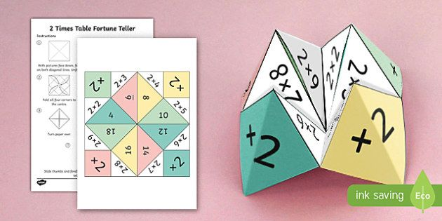 | Maths  Create a spider graph of different number sentences for a multiplication table.  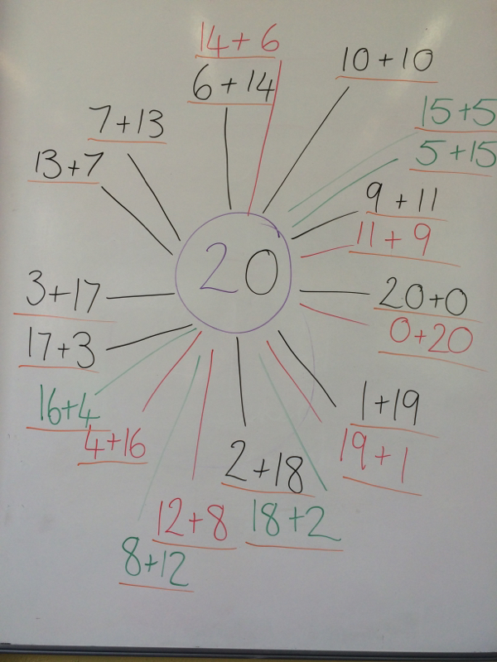 | Maths  Write your own word problem for a known multiplication.  E.g. Mrs Mac has 10 pairs of shoes. How many shoes does she have altogether?  Note: Drawing pictures of the problem will help with understanding
English Overview: This week, we are continuing with our topic on Stories about Imaginary Worlds.
Definition and examples – An imaginary world is a place that only exists in your mind or in a story or a film. It is not a real place like a supermarket or a forest, but one that can be as magical or as fantastical as possible.
Useful websites - https://nosycrow.com/blog/best-imaginary-worlds-in-children-s-books/
https://www.bbc.co.uk/bitesize/topics/z6vv4wx/articles/z24rxfr
Recommended Reading - Beyond the Pond – by Joseph Kuefler. Pool – by JiHyeon Lee. This is Sadie – by Sara O’Leary. Journey and Quest – by Aaron Becker. Where the Wild Things are – by Maurice Sendak
Monday | Tuesday | Wednesday | Thursday | Friday
English  Reading  Watch the clip…  https://www.youtube.com/  watch?v=ALmNPxNehYE  Listen to the story, ‘Where the Wild Things Are’.  This is one of the best videos of the story being read aloud, as you can see the words at the same time too. Please make sure you watch clips on Youtube with an adult. | English  Reading  Draw a picture of where the wild things live.  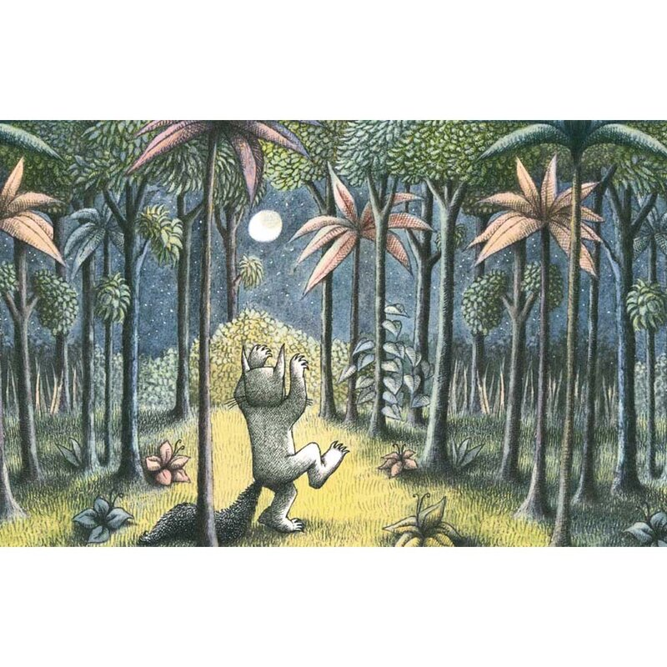 | English  Writing  Choose adjectives from the list below to describe your picture. Write them around your picture. Can you think of some more?  magical  enchanted  dazzling  dark  mysterious | English  Phonics  Explore the following website with lots of games and activities to play online…  http://www.letters-and-sounds.com/phase-2-games.html | English  SPG  Do a look, cover and write with the following words…  that  this  thin  thick  then  What was your score? Can you think of any more ‘th’ words?
PSHE Overview: This week, we are starting our topic on Positive Friendships and Feeling Happy.
Definition and examples – We will be thinking about what makes a good friend, what is a positive and healthy relationships? We will also be addressing issues such as personal space, positive and negative touch and stranger danger.
Useful websites - https://www.mentallyhealthyschools.org.uk/resources?gclid=EAIaIQobChMI7cH8-eaE7gIVrIBQBh37NwCGEAAYAiAAEgIy9fD_BwE
https://www.youngcitizens.org/unique-offer-for-go-givers-subscriptions?gclid=EAIaIQobChMI7cH8-eaE7gIVrIBQBh37NwCGEAAYAyAAEgKtivD_BwE
https://www.bbc.com/ownit http://www.safetynetkids.org.uk/ https://www.bbc.co.uk/bitesize/topics/zswwxnb
Monday | Tuesday | Wednesday | Thursday | Friday
PSHE  Create a recipe for a friend.  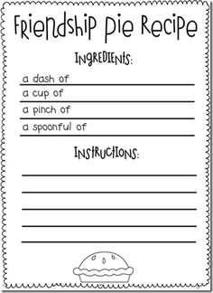  E.g. A dash of kindness  A cup of loyalty  A pinch of fun etc | PSHE  Write a set of friendship rules for our classroom.  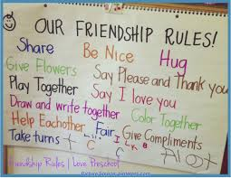 | PSHE  Watch the clip…  https://www.bbc.co.uk/  bitesize/clips/zwfhfg8  Write a letter to a friend you have not seen in a while. | PSHE  Be a good friend at home. Help around the house.  Can you help with the dishes, help to lay the table, help to tidy your room or help to feed a pet?  Take a picture of you helping and put it on Evidence for Learning. | PSHE  Go to Discovery Education/Espresso  Watch the story of Little Beaver and the Echo on Story Time Rat-a-Tat-Tat.  Try some of the activities linked to the story too.  Username: student7070  Password: green3
PE  Try doing some cosmic yoga this week…  https://www.youtube.com/  watch?v=b5LLfdhGekA  Linked to our topic on friendship | PE  Cosmic Yoga  https://www.youtube.com/  watch?v=KMY2pMsLiJw  For relaxation | PE  Cosmic Yoga  https://www.youtube.com/  watch?v=K7FUbTac_ds  For meditation | PE  Cosmic Yoga  https://www.youtube.com/  watch?v=Rzw-Oir8UPw  Linked to our topic in DT | PE  Cosmic Yoga  https://www.youtube.com/  watch?v=uUIGKhG_Vq8  To help with listening
ART  Our topic this term is Working the Surface.  Follow the tutorial on the website with an adult to create a textured leaf painting.  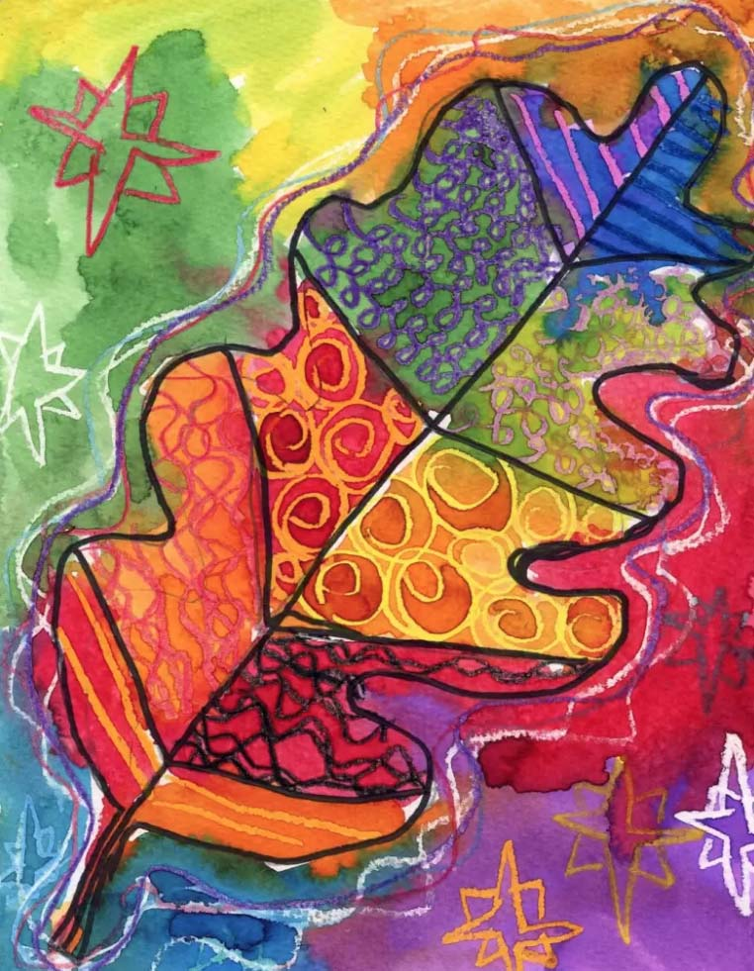  If you don’t have watercolour paint, ordinary paint mixed with water will work as well. | RE  Our topic this term is Islam  Explore the topic page on Espresso all about Islam.  Watch the video – An introduction to Islam.  Have a go at some of the activities linked to the topic.  Username: student7070  Password: green3 | Food Technology  Create a healthy snack. Write a recipe for your snack and have a go at making it.  Watch the clip on BBC Bitesize for some ideas.  https://www.bbc.co.uk/  bitesize/clips/zwgnvcw  Take a photograph of your snack for Evidence for Learning. | SCIENCE  Our topic this half-term is Rocks and Where do rocks Come From?  Check out the module on Rocks on Discovery Education/Espresso  Watch the video on different types of rocks.  Write the name of the three different types of rocks. | COMPUTING  Take part in the Online Safety Quiz on Discovery Education/Espresso.  Check out your score against Polly, Eddy, Sal and Scrap!  Username: student7070  Password: green3

