Badger Class Summer Term 2023

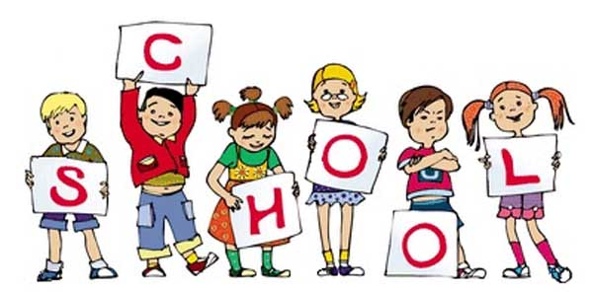

Badger class staff.

Ms K.White/Ms Haworth

Ms J.Forrest

MrT. Medcalf (1:1)

**Topics**

**Summer 1 –** Classic fiction

**Summer 2 -** Topical stories/Real life issues

**Ongoing** - Spelling and Phonics, Guided Reading, Guided Writing, Handwriting.

Speech and language work.

**Topics**

**Summer 1 -** Measures

**Summer 2 -** Multiplication and division.

Facts, written methods and problem solving.

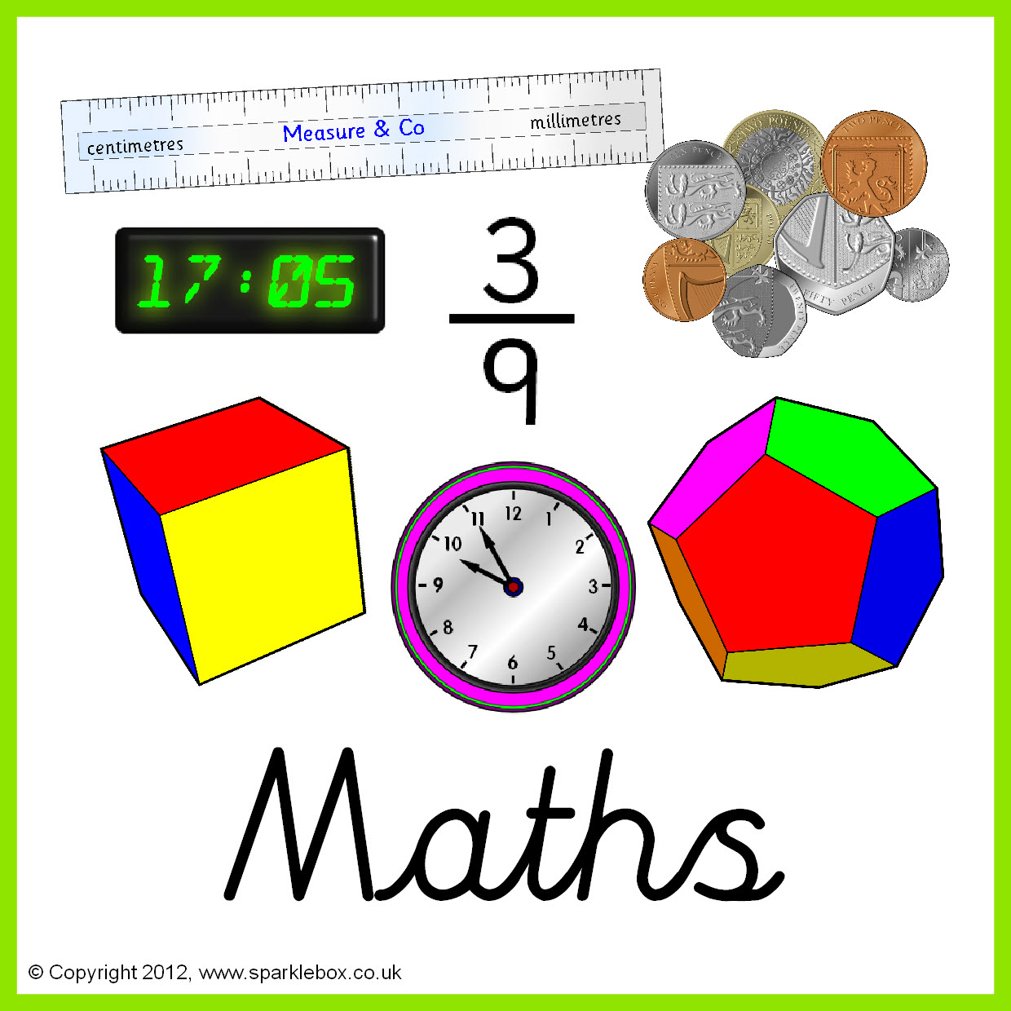

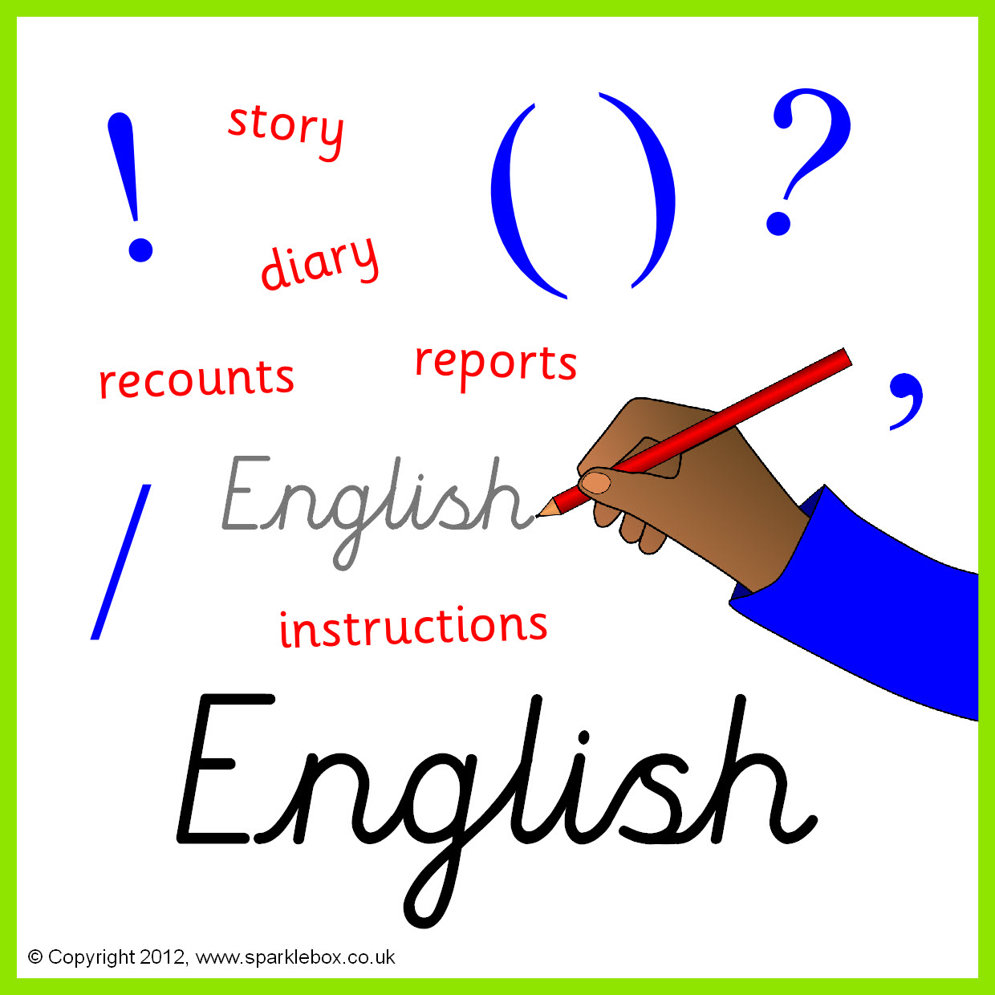

**Topics**

**Summer 1 –** Chemical reactions.

**Summer 2 –** Structure and function of living organisms.

**Topics**

**Summer 1** – E safety.

**Summer 2** –Spreadsheets.

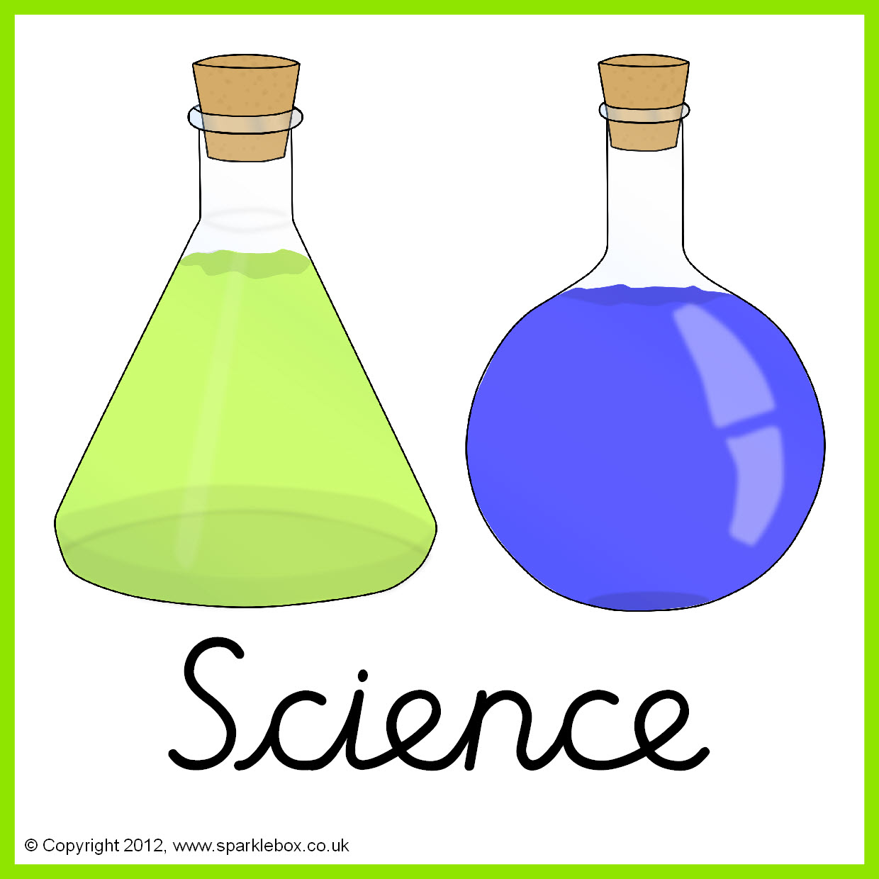



**Topics**

**Summer 1** – Pop art

**Summer 2- sgraffita.**

**Topic**

Weather around the world.







**Topics**

**Summer 1** – Colours and flags

**Summer 2** – Days of the week

**Topic**

Crime and punishment – then and now.



**Topics**

**Summer 1** – Target games

**Summer 2** – Tennis/ Athletics

**Topics**

**Summer 1-** Various Religions – What is worth celebrating?

**Summer 2** – Islam





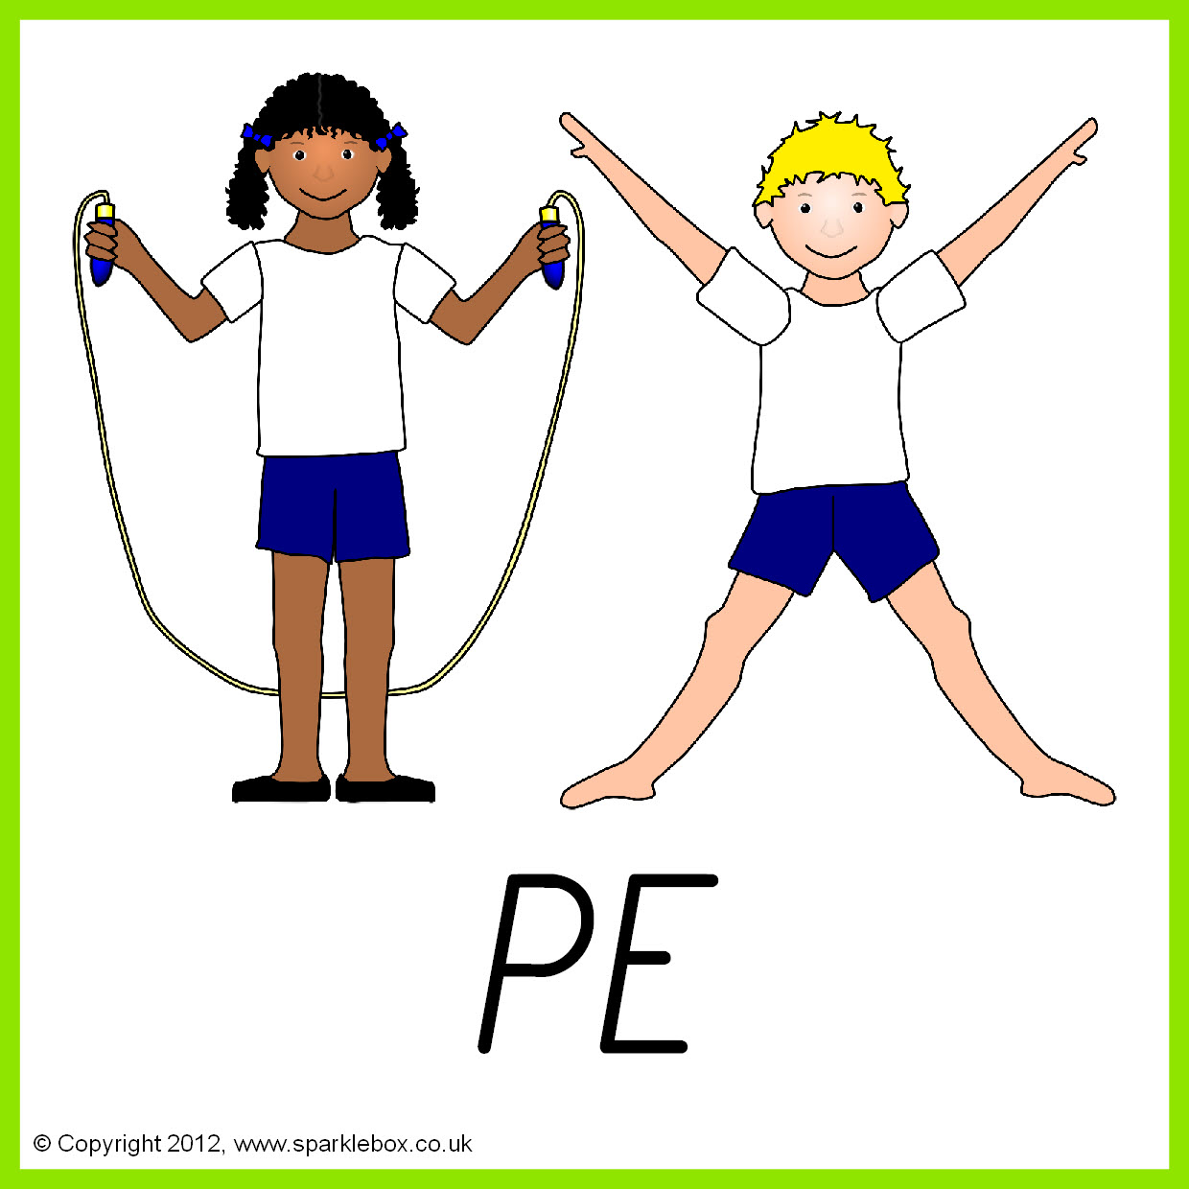

**Topics**

**Summer 1** – Jewellery design and make.

**Summer 2** – Making snacks.

**Topics**

**Summer 1** – healthy balanced life.

**Summer 2** – Looking ahead – options for the future.

.

