SPRING/SUMMER 2021 MENU – WEEK 3
OPTION | MONDAY |  | TUESDAY |  |  | WEDNESDAY |  |  | THURSDAY |  |  | FRIDAY
1 | Fish fingers, mash potatoes baked beans or peas | 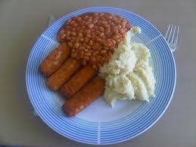 | Roast turkey,  stuffing  roast and creamed potatoes, carrots, broccoli and gravy |  |  | Chicken tikka masala with rice |  |  | Pork meatballs (veggie option available) in tomato sauce with pasta and peas | 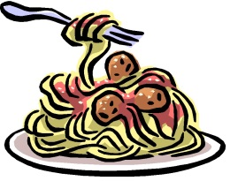 |  | Fish, chips, beans or peas
2 | Pasta in a tomato sauce, with broccoli | 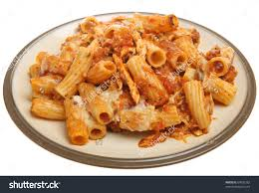 | Ham & Cheese pasta bake with carrots & broccoli | 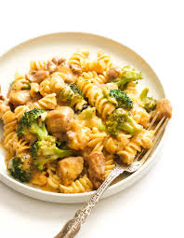 |  | Panini, salad and coleslaw | 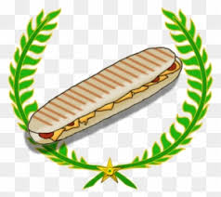 |  | Tuna and cheese puff with herby diced potatoes and peas |  |  | Seasoned chicken fillet, chips, peas or baked beans
V
JP | Filled  Jacket  Potato |  | Filled  Jacket Potato |  |  | Filled  Jacket Potato |  |  | Filled  Jacket Potato |  |  | Filled  Jacket Potato
 | Available daily as an alternative: - Sandwiches served with vegetables, a dessert and drink
DESSERTS
 | Ice cream |  | Yoghurt/Fruit |  | Flapjack |  |  | Jelly |  |  | Toffee date cake
Vegetarian alternative:- Fruit yoghurt, a selection seasonal fresh fruit, soreen and cheese & biscuits available everyday
Unlimited fresh salad and unlimited wholemeal bread
LUNCH WILL BE SERVED WITH FRESH MILK OR WATER
Menu Cycle Week 3: 10th May, 31st May, 21st June, 12th July

