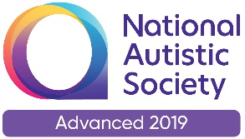 |  | Paul King  Headteacher  Joanne Mullineux  Deputy Headteacher
14th December, 2020

Dear Parents / Carers

Contacting school / College over the Christmas period

You may be aware that schools have been asked to be the contact point for parents / staff for six days after we close on Friday 18th December. This would take us to Christmas Eve – Thursday 24th December. The government have asked schools/colleges to do the following.

- For the first 6 days after teaching ends from 3pm on Friday 18th December, if a pupil or staff member tests positive for coronavirus (covid-19), having developed symptoms within 48 hours of being in school, the school is asked to assist in identifying close contacts and advising self-isolation, as the individual may have been infectious in school.

- Where a pupil or staff member tests positive for coronavirus (covid-19), having displayed symptoms more than 48 hours since being in school/college (by 3pm on Sunday 20th December) the school should not be contacted. Parents and carers should follow contact tracing instructions provided by NHS Test and Trace.

To stream-line this potential reporting system we are suggesting that all parents of Green Lane pupils and all College students (Fox Wood and Green Lane included) contact the Green Lane School email address: greenlane_school@warrington.gov.uk reporting the positive case. The school will be checking the email address each day for the six days up to 24th December. If a positive case is reported then we will contact Test and Trace and other pupils / staff who may have been in close contact with that pupil or member of staff and advise them to self-isolate.

I would like to take this opportunity to thank you all; Parents for your continuing support to our school, to the staff who have worked tirelessly to safely deliver the curriculum and to ensure the wellbeing of the children and to each other and to the children who have been amazing.

The school closes on Friday 18th December and reopens on Monday 4th January.

Have a very Merry but safe Christmas and all the best for 2021.

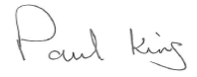
Paul King
Headteacher

