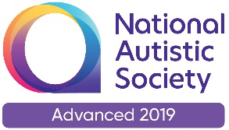 |  | Paul King  Headteacher  Joanne Mullineux  Deputy Headteacher

3rd March, 2021

Dear Parents/Carers

Further opening of school from Monday 8th March

As we expect the return of more of our children to school next week I just thought I would write to you to give you some details of the return.

Transport
Transport section will be informed of your child’s return to school and if they are transported to and from school by school transport you will be informed of pick up and drop off times. We have been informed that some routes will have to make ‘double’ runs so pick up and drop off times might be slightly different for some children.

For those parents dropping off / picking up their own child could you arrive after 9am in the morning and for children in Class 1, 2 3, and 3N could you collect them at 2-45pm from the school front entrance. For older children could arrive after 3-25pm once the buses have cleared.

School dinners
We have not returned to full school dinners in the school hall as yet with the children eating their lunches in their classrooms. If you want your child to have a school dinner then the usual ordering and payment arrangements apply.

School uniform
There is an expectation that all children will be in school uniform when they return. Please contact your child’s class teacher if there is a problem with this.

Vaccinations / home test kits
All staff who wanted a vaccination have now had one. They will be provided with lateral flow kits to test themselves twice a week from next week. We are awaiting the arrival of pupil home test kits which can be used to test your child at home. This is not compulsory. As soon as the kits arrive we will get them out to you. Instructions for their use are within the pack.

Wearing face masks/coverings
All upper school pupils are required to wear a face mask/face covering when moving around the school (unless they are exempted.) If children want to wear their face mask / face covering in class they may do so but we are not asking them to do this.

Over the next four weeks we will be returning the children to a timetable that they are used to. We will be concentrating our efforts on ensuring they are comfortable back in school and get their learning to where it was pre-lockdown.

If you have concerns or questions please contact, in the first instance your child’s class teacher or myself if required.

Yours sincerely

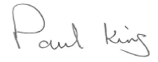
Paul King
Headteacher

