Badger class staff.

Ms K.White

Ms J.Forrest

Badger Class Spring Term 2024



**Topics**

**Autumn 1**

Class Novel

**Autumn 2**

Class Novel

**Ongoing** - Spelling and Phonics, Guided Reading, Guided Writing, Handwriting.

Speech and language work.

**Topics**

**Autumn 1 -**

**Multiplication and Division**

Mental strategies.

Multiply 2 or 3 digit numbers by a single digit using a written method.

**Autumn 2 – Measures**

Tell time using an analogue clock.

Convert between analogue and digital time.

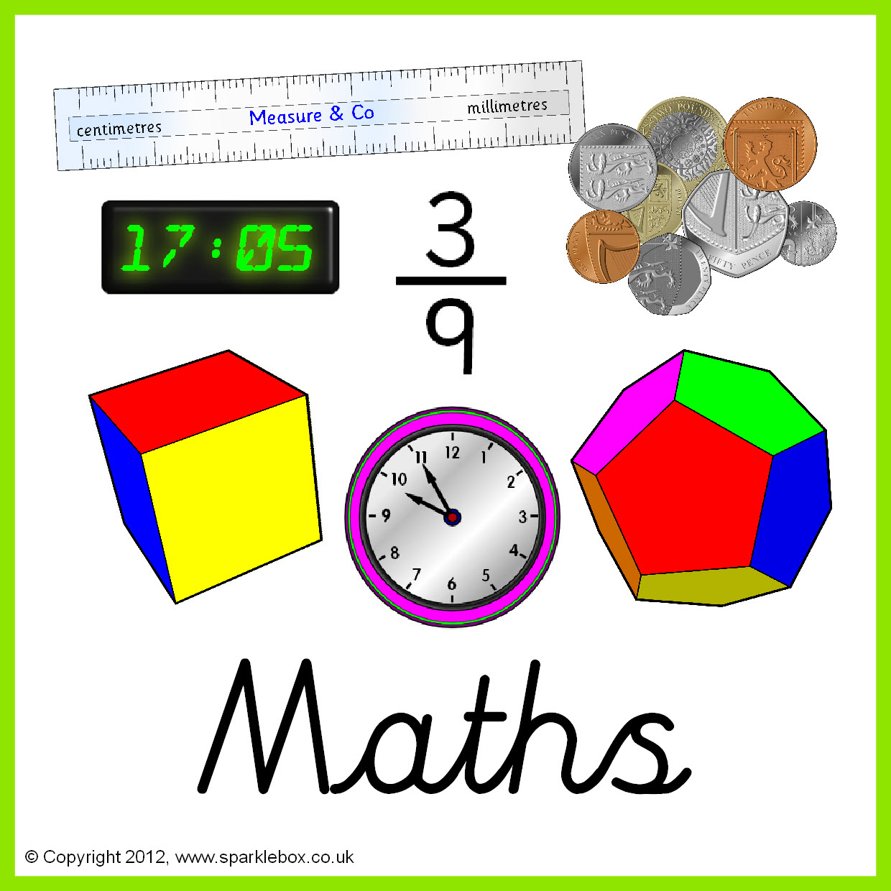



**Topics**

**Autumn 1 –** Animals including humans – development.

**Autumn 2 -** The sun, moon and Earth.

**Topics**

**Autumn 1** – Data handling

**Autumn 2** - Multimedia





**Topics –**

**Autumn 1** – Everyday objects.

**Autumn 2** – Imaginative landscapes.

**Topics** -

Extreme and Natural disasters.







**Topics -**

**Autumn 1** - Months of the year.

**Autumn 2** – Numbers to 30

Spanish greetings- My name is.

**Topic** -

The Ancient Greeks and the Olympics.



**Topics -**

**Autumn 1** – Gymnastics.

**Autumn 2** – Basketball.

**Topics** - **Autumn 1** – Sacred texts: Quran and Bible.

**Autumn 2** – Easter Story and Sikh and Hindu places of worship.





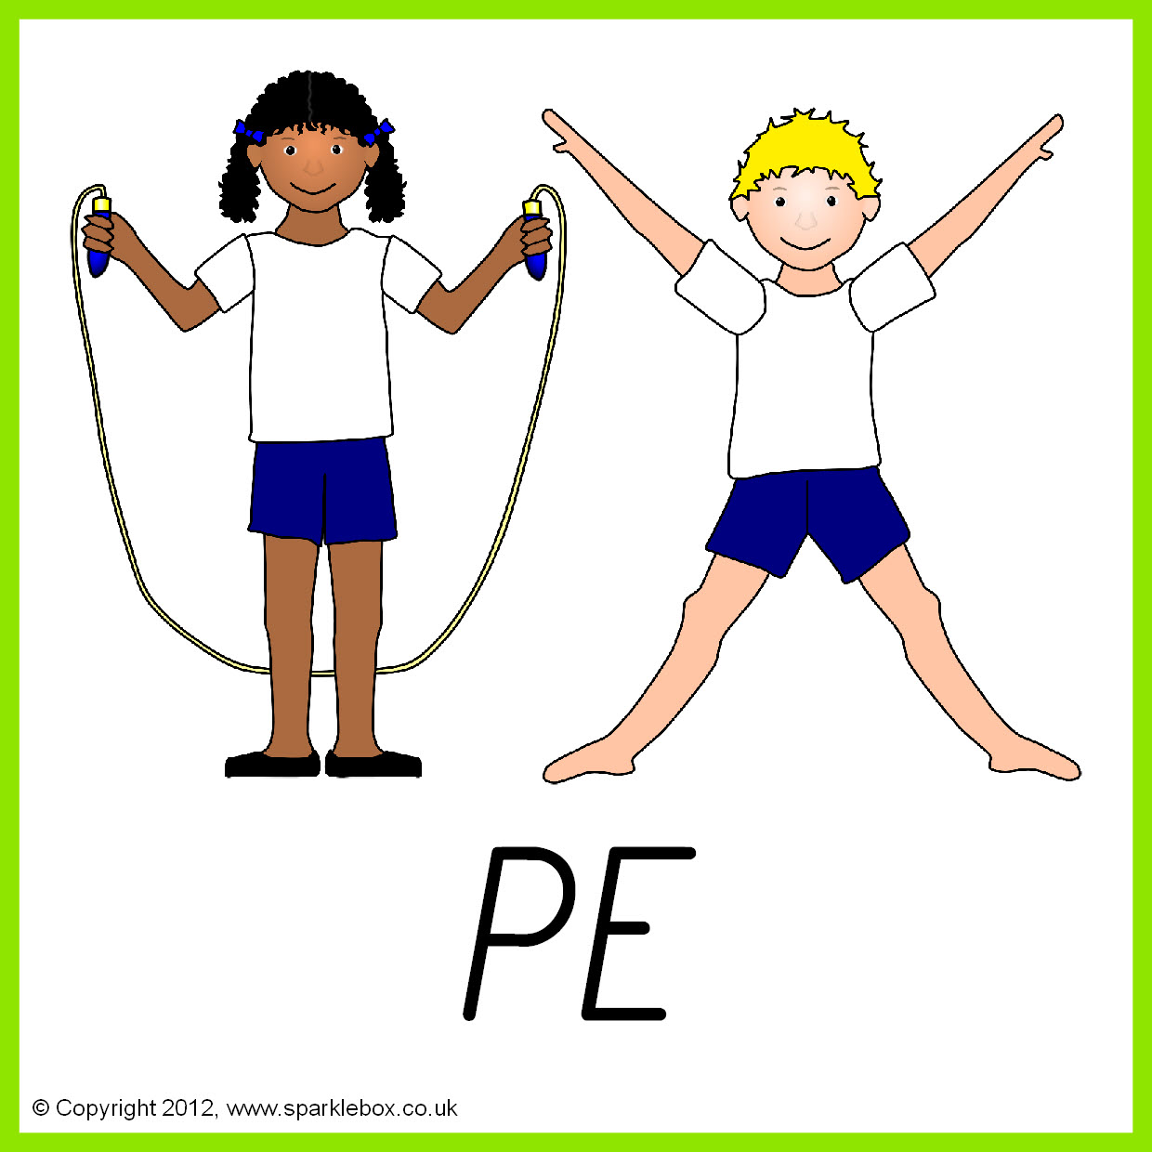

**Topics** - **Autumn 1 –** Changing adolescent body.

**Autumn 2** – New relationships.

**Topics - Autumn 1 –** Electrical: How things workin the kitchen.

**Autumn 2 –** Ways with eggs.

**Autumn 2 – Basic food hygiene – Winter warmers.**

