Topics

Number

Measures

Maths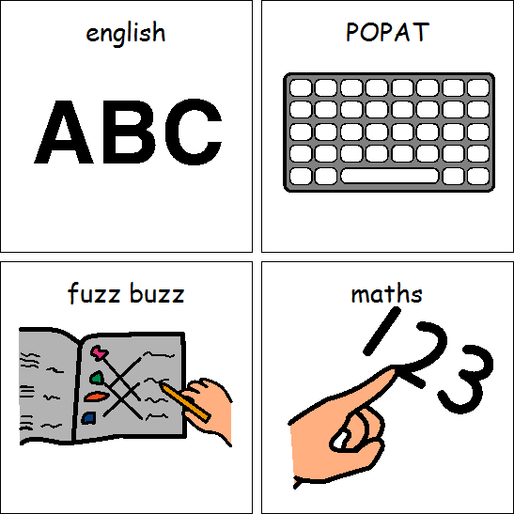

Games

Core skills

PE

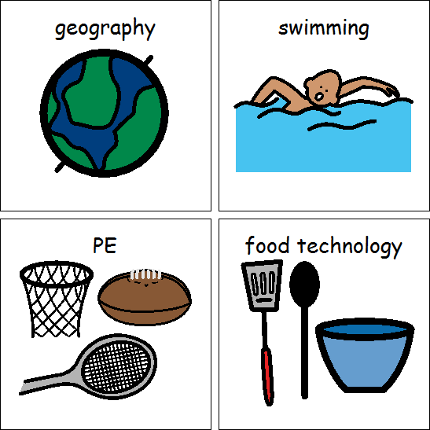

Computing

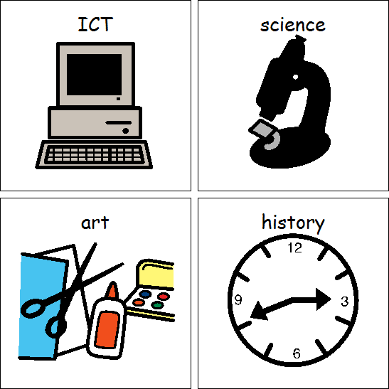

Topics

*Taught cross-curricular*

Sound and music

Programming and algorithms

Topics

*Taught through Spanish themed afternoons*

Numbers to 5

All about Spain

Languages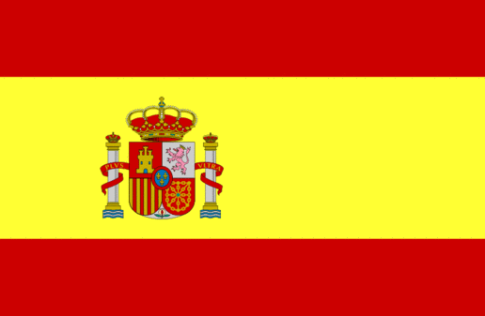

Topic/SCERTS (Covers English, Science, DT, RE, Art, Geography and History)

**Toys**

English: Instructions and exploring characters

Science: Pushes, pulls and messy magnets and why does it move?

History: What toys did my grandparents play with?

Geography: London

Art: Sculpture

DT: Mechanisms (levers and axis)

Food Technology: Treat boxes

RE: The Good Samaritan and Easter: Symbols

Class 6B Spring 2021