
Home Learning Activities
English  Listen to this Winter song to warm up!  https://www.youtube.com/watch?v=uY3w_v6Ua9U  Work pack activity:  Depending on the activity in your work pack can you either:  - LO: To add writing to add meaning to a picture.  Draw your own Winter image in the box. Now can you write some sentences describing your image?  Challenge: To label a simple diagram worksheet.  - LO: To match letters to Winter words.  Look at the pictures. Can you cut out the letters and match them to the correct sound?  Challenge: To trace circular and straight movements worksheet. | Maths  LO: To order numbers using a criteria.  Work pack activity:  Depending on the activity in your work pack can you either:  a) Look at the numbers. Can you order them from smallest to largest, and then from largest to smallest?  Use this game to help you practise! https://www.topmarks.co.uk/ordering-and-sequencing/coconut-ordering  b) Can you cut out the numbers and order them from smallest to largest on your number line? You have 2 themes – teddy bear and penguin ordering. Use this game to help you practise!  https://www.topmarks.co.uk/ordering-and-sequencing/caterpillar-ordering | PSHE  LO: To identify why I am a good friend.  Watch this video:  https://www.youtube.com/watch?v=ReMq3KX8F94  Do you think you are a good friend?  Work pack activity:  Using the resources in your work pack can you create a friendship flower?  Stick your photo in the middle of the flower and list all of the reasons why you are a good friend on the petals using the symbols provided.  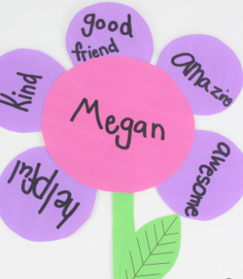 | Science  LO: To describe rocks and soil.  If possible and safe to do so, can you go outside and find a rock or some soil?  How does it feel?  Work pack activity:  Look at the pictures on your worksheet. Can you think of any words to describe the rocks?  Depending on the activity in your work pack can you either:  - Write some describing words on the lines provided to describe each rock. Use the second sheet to help you.  - Look at the describing words provided for you. Can you choose one that describes each rock? Stick the symbol next to each picture. | Life Skills  LO: To understand how to wash my hands properly.  Watch this video:  https://www.bbc.co.uk/cbeebies/watch/germs-experiment  Why don’t you try this experiment yourself? Don’t forget to upload a picture to EFL!  Work pack activity:  Depending on the activity in your work pack can you either:  a) Draw and colour your own pictures to match the steps of handwashing.  b) Cut out the pictures and match them to the correct step of handwashing.  Now make sure that you wash your hands properly every time!  https://www.youtube.com/watch?v=dDHJW4r3elE
Class: 4 Week Beg: 01/02/21 Your work pack includes other resources to help assist your child’s learning. Please use these alongside the lessons below.

