
Home Learning Activities
Class: P3 Week: 4
Monday | Tuesday | Wednesday | Thursday | Friday
Maths  Reading and writing the time to o'clock and half past (Part 1)  In this lesson, you will be reading, writing and telling the time to o'clock and half past  https://classroom.thenational.academy/lessons/reading-and-writing-the-time-to-oclock-and-half-past-part-1-6wwpat | Maths  Reading and writing the time to o'clock and half past (Part 2)  In this lesson, you will be reading, writing and telling the time to o'clock and half past  https://classroom.thenational.academy/lessons/reading-and-writing-the-time-to-oclock-and-half-past-part-2-c4wkjr | Maths  Reading and writing the time to o'clock and half past in words  In this lesson, you will be reading, writing and telling the time to o'clock and half past  https://classroom.thenational.academy/lessons/reading-and-writing-the-time-to-oclock-and-half-past-in-words-6xj3ac | Maths  Explore adding on hours and half hours  In this lesson, you will be adding either one hour or half an hour onto a given time.  https://classroom.thenational.academy/lessons/explore-adding-on-hours-and-half-hours-6njpad | Maths  Using language of direction, position and movement  In this lesson, you will be using directional language when moving and giving instructions for someone else to move.  https://classroom.thenational.academy/lessons/using-language-of-direction-position-and-movement-c9h30d
English  Using your knowledge of recounts, write a recount about your activities last week.  Remember to put it in time order and try to add detail into it that the reader would want to know. | English  Watch the video of ‘Pandora’s box’  https://www.youtube.com/watch?v=rNk-zV2T7bI  Answer the questions about the story. | English  Draw a picture of two big boxes label one ‘hope and dreams’ and the other ‘fear’  Think about what would be in your boxes.  Write down all your hopes and dreams in one box and write down your fears in the other box. | English  I have sent you a worksheet focusing on full stops and capital letters remember our rules for capital letters and see if you can work out where they should go.  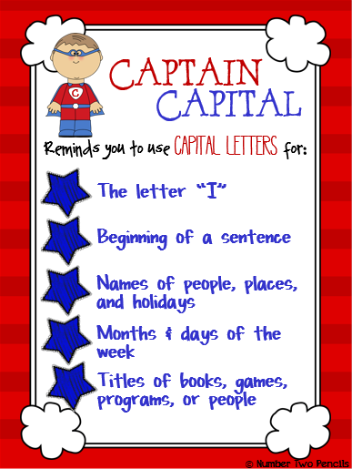 | English  When Pandora opened the box all the bad things escaped eg. Hunger, war, pain. This made all the people in the world sad. She also let out hope to try and help beat back the bad things.  Can you write a letter from Pandora telling the world what she has done?
History  How has food changed in the last 60 years?  In this lesson, we will be learning about some of the ways in which food has changed over the last 60 years. We will learn how modern technology has made it easier to cook and eat food and will look at some examples of popular dishes from the 1960s to 1990s. You will need a piece of paper and a pencil.  https://classroom.thenational.academy/lessons/how-has-food-changed-in-the-last-60-years-60u6cd | History  Where does our food come from?  In this lesson, we will be learning about where some of the food that we eat comes from. We will look at some of the most popular foods from other continents. You will need a piece of paper and a pencil.  https://classroom.thenational.academy/lessons/where-does-our-food-come-from-75hk8e | Science  Which materials float and sink?  In this lesson, we will be investigating different materials and their properties. We will be exploring which materials float and which materials sink, then we will be making comparisons while looking at their properties. Do all hard materials sink? Do all soft materials float? You will need a piece of paper and a pencil. If you would like to take part in the experiment you will need a coin or small metal object, a cotton ball or pad, stones, a pencil and a bowl of water. Otherwise, you can watch me conduct the experiment while observing the outcomes.  https://classroom.thenational.academy/lessons/which-materials-float-and-sink-cdj66c | Geography  How do people move around in London?  In today's lesson, we join Miss Browne in learning about the different modes of transport used by people in London. We consider which of these modes of transport are the cleanest, and the negatives and benefits of each. We finish the lesson by having a go at reading a London Underground map.  https://classroom.thenational.academy/lessons/how-do-people-move-around-in-london-68wkat | PE  Complete a workout with Joe Wicks or have a go at some Cosmic Kids Yoga.  https://www.youtube.com/user/thebodycoach1  https://www.youtube.com/user/CosmicKidsYoga

