Home Learning Activities
Class: Q3 Week: 3 Week Beg: 18.01.2021

Monday | Tuesday |  | Wednesday |  | Thursday | Friday
Maths  KH/ZS/IS/HC/MG/GW/KL/DHG – Use the hundred square to +10 to each number (see attached.)  KM/LR – Counting in 50s (see attached.) | Maths  KH – Complete the counting sequence (raindrops - steps of 1, see attached.)  ZS/IS/HC/MG/GW/KL/DHG - Complete the counting sequence (kites - steps of 10, pages 3+4, see attached)  KM/LR – Counting in 50s (see attached.) |  | Maths  Play a game with someone in your family!  KH/ZS/IS/HC/MG/GW/KL/DHG – Snakes and ladders (see attached.)  KM/LR – Doubling space race! (see attached.) |  | Maths  KH – Group 1 addition word problems (see attached.)  KH/ZS/IS/HC/MG/GW/KL/DHG – Addition and subtraction two step word problems (see attached.)  KM/LR – Group 3 addition and subtraction word problems (see attached.) | Maths  TT Rock stars – Practise your tables!
English  Look at the leisure facilities in Warrington (attached.)  Discuss - where is each facility? Have you been there before? What did you do there? | English  Pick one of the leisure facilities (or your own) to research further. Find out and record key information on the research activity sheet (see attached.) |  | English  Look at https://www.tripadvisor.co.uk/ What are the 5 most popular attractions in Warrington? |  | English  Using trip advisor look at the reviews for the top 5 places to visit in Warrington. Which would you want to visit first?  Write a sentence explaining why. | English  Spelling test.
PSD/ASDAN  Consider the skills and qualities that you have. Do you have the skills and qualities specified in the job description you researched last week?  Complete ‘what are my skills and qualities’? (Attached.) |  |  |  |  | PSD/ASDAN  Complete the job application form (attached,) for your chosen job.
PE  Imagine that you are in a swimming pool, think about the strokes (front crawl, breast stroke.) ‘Swim’ across your front room using a different stroke for each direction. |  | PE  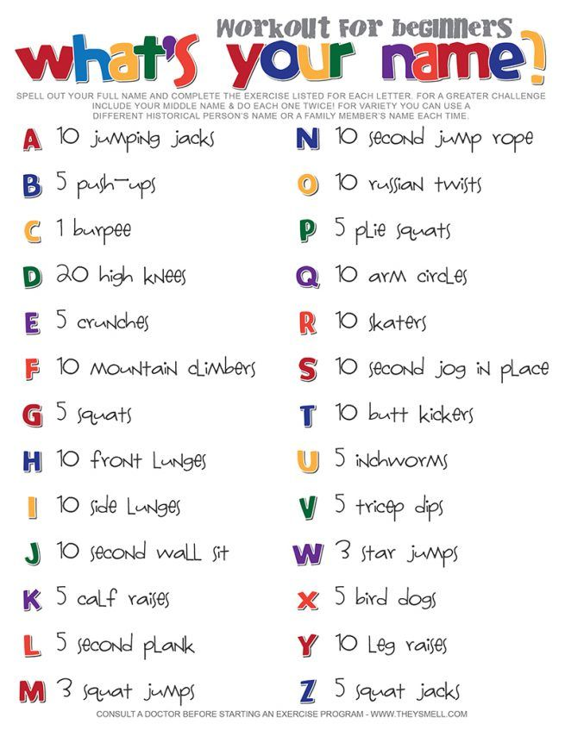 |  | PE  https://www.youtube.com/watch?v=DCknJsiqPVg  Just Dance 2021: Dance Monkey  Test your dance moves and then pick one more Just Dance tracks to try! | PE |  | PE  https://www.youtube.com/watch?v=rN0h6EZd6TM  5 minute move
Phonics
Practice your spellings.
Phase 2 – et/id – let, met, net, pet, set, vet, wet, yet, bid, did
Phase 3 – fr/gr/pr/tr – frost, grab, grill, grin, grip, pram, prick, prod, track, trap
Phase 4 – ay – always, away, clay, day, display, gay, hay, holiday, may, pay
Phase 5 – ed – played, sailed, looked, cooked, soaked, booted, floated, heated, invented, noted
Phase 6 – silent - numb, thumb, debt, doubt, rhubarb, rhyme, castle, wrap, wrapper, wreck
Science  Read through the victim profiles from last week.  Complete the table saying what injuries each victim sustained and what the suspected weapon used was.  Discuss ‘what did this evidence tell them about Jack the Ripper’? E.g. Did they suspect that he had a medical background? | Food wise  Before your family go shopping agree on a meal that you can buy as a ready meal. Make the ready meal and score it out of 10 for its appearance and taste. With a little help research a recipe for the same meal and have a go at cooking the same meal for you and your family. Again score it out of 10 based on its appearance and taste.  Which did you prefer and why?  Don’t forget where possible please upload evidence of your completed work to EFL.

