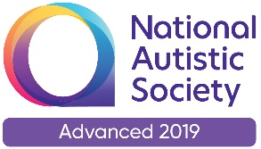 |  | Paul King  Headteacher  Joanne Mullineux  Deputy Headteacher

26th June 2020

Dear Parents / Carers

Further expansion of school from Monday 29th June 2020

It has been lovely seeing the return of more of our pupils over the past two weeks. You know it is our ambition to have all of our pupils in school before we break for summer. Next week will see just over 100 pupils attending school on Monday, Tuesday, Thursday and Friday. Wednesday will be our cleaning / PPA day. I understand that for some families a part-time timetable has massive impact on a return to work for parents. I understand this but as all our pupils have EHCPs then they are all entitled to return to school. We are unable to organise our classes in the same way as before lockdown. We therefore have to reduce the amount of time each child spends in school. This for me is the fairest way of allocating places given the demand.

The following points will hopefully help with the smooth transition back to a ‘normality’.

Transport arrangements
- Your child will either be transported in by minibus or you have chosen to bring them into school.
- Drop off is from 8-40am (if on transport) and after 9am if brought in by a parent.
- Pick up is from 3-15pm for provided transport and after 3-25pm for parents.
- If the bus bays have been cleared parents can use them to drop off or pick up. However if minibuses are still around please park on the carparks.
- Please be extra vigilant on the site as there is likely to be more traffic.
- We have been informed that some pupils may have to be dropped off and picked up later as a result of ‘double runs’ of some transport.
- Pupils will be socially distanced on the transport and they may wear face masks if they want to.
Measures in school
- We have carried out an extensive risk assessment which we will follow. This is available to see on the website.
- All classrooms have been deep cleaned.
- There is a cleaning checklist for classrooms that is carried out throughout the day.
- Pupils remain in their bubbles for lessons, lunch and breaks. Mixing of bubbles is discouraged as far as is possible.
- Pupils do not have to wear school uniform. They should have a change of clothes every day.

We hope these measures reassure you about what we are doing in school. They are designed to keep your child, other children and staff safe.

If you would like to discuss any of the above with me, please feel free to contact me in school.

Yours sincerely

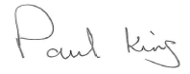

Paul King
Headteacher

