SPRING/SUMMER 2021 MENU – WEEK 2
OPTION | MONDAY |  | TUESDAY |  |  | WEDNESDAY |  |  | THURSDAY |  |  | FRIDAY
1 | Pizza, herby diced potatoes. peas or sweetcorn |  | Roast gammon,  roast & mashed potatoes, carrots, broccoli & gravy | 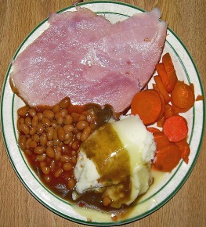 |  | Pasta carbonara with carrots & sweetcorn | 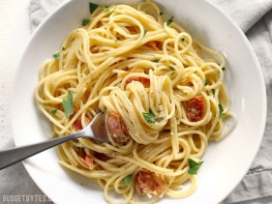 |  | Chicken Balti with rice |  |  | Salmon, chips with peas or baked beans
2 | Tortilla boats filled with mild chilli beef, rice and sweetcorn | 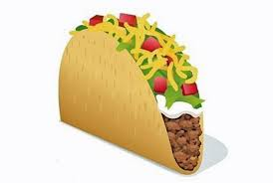 | Tomato & mascarpone pasta bake with broccoli | 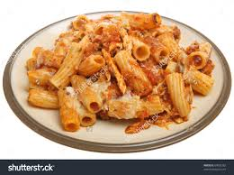 |  | Panini, salad and coleslaw | 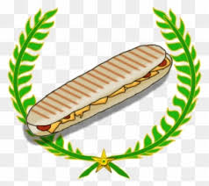 |  | Veggie sausage roll, sauté potatoes & baked beans | 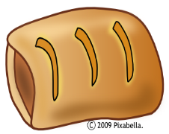 |  | Chicken poppers, chips with peas or baked beans
V
JP | Filled  Jacket Potato |  | Filled  Jacket Potato |  |  | Filled  Jacket Potato |  |  | Filled  Jacket Potato |  |  | Filled  Jacket Potato
 | Available daily as an alternative: - Sandwiches served with vegetables, a dessert and drink
DESSERTS
 | Vanilla ice cream |  | Yoghurt/Fruit |  | Chocolate cake |  |  | Fruit mousse |  |  | Cookie
Vegetarian alternative:- Fruit yoghurt, a selection seasonal fresh fruit, soreen and cheese & biscuits available everyday
Unlimited fresh salad and unlimited wholemeal bread
LUNCH WILL BE SERVED WITH FRESH MILK OR WATER
Menu Cycle Week 2: 3rd May, 24th May, 14th June, 5th July

