Draw the clock hands for the time written below.
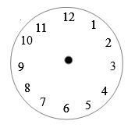
half past 5 quarter past 2 quarter past 12
8 0’clock half past 11 quarter past 8
half past 9 4 0’clock quarter past 1
quarter past 6 half past 2 half past 12

