Spring/Summer 2021 MENU – WEEK 1
OPTION | MONDAY |  | TUESDAY |  |  | WEDNESDAY |  | THURSDAY |  |  | FRIDAY
1 | Pasta Bake, peas & sweetcorn | 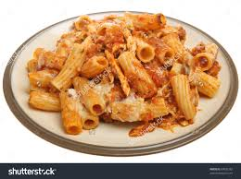 | Roast turkey with sage and onion stuffing with roast & creamed potatoes. Fresh broccoli or carrots Gravy |  |  | Homemade chicken korma & rice |  | Spaghetti Bolognaise & peas |  | 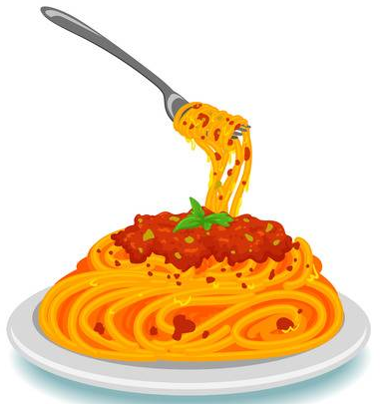 | Fish stars chips and peas or beans
2 | Assorted Paninis, coleslaw and salad | 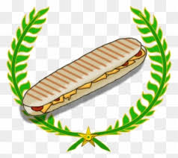 | Homemade Macaroni cheese with broccoli. |  |  | Pork sausage, mashed potato, carrots, peas & gravy | 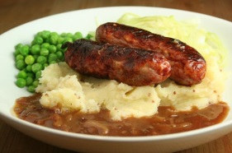 | Gammon, saute potatoes, beans or peas |  | 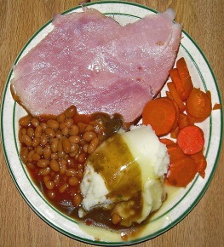 | Crumb coated chicken, chips, peas or beans
V |  |  |  |  |  |  |  |  |  |  | Cheese Flan, chips. Peas or beans
JP | Filled  Jacket Potato |  | Filled  Jacket Potato |  |  | Filled  Jacket Potato |  | Filled  Jacket Potato |  |  | Filled  Jacket Potato
 | Available daily as an alternative: - Sandwiches served with vegetables, a dessert and drink
DESSERTS
 | Vanilla ice cream |  | Yoghurt or Fruit |  | Blueberry Cake |  |  |  | Fruit Jelly |  |  | Shortbread Biscuit
Unlimited fresh salad and unlimited wholemeal bread
LUNCH WILL BE SERVED WITH FRESH MILK OR WATER
Menu Cycle Week 1: 17th May,7th June,28th June,19th July

