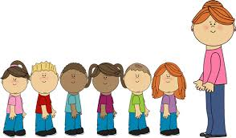

Letters and sounds.

Nursery rhymes.

Sharing texts and stories. Letters: m,d,g,o,c,k



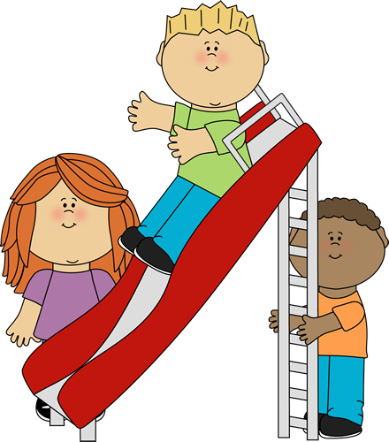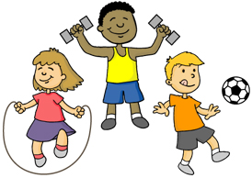

Using PECS/ Makaton.

Identifying action words.

Initiating interactions with others.

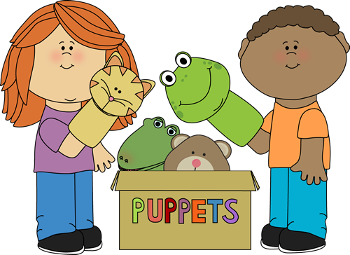

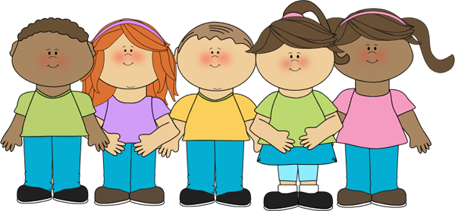

Physical Development

Communication and language.

Class 1 Staff

Mrs C Skermer

Miss H Chadwick

Mrs K Lothrop

Mrs G Phillips

Our curriculum is based on the EYFS strategy. We encourage the children to explore and learn through play.

Class 1 Spring 2021

Developing fine and gross motor skills.

Using sensory regulation activities.

Enjoying mark-making.

Expressing preferences.

Playing alongside others.

Sharing joint attention.

Telling others when I am happy or sad.

Mixing colours.

Creating patterns.

Dance.

Music.

Exploring using all the senses.

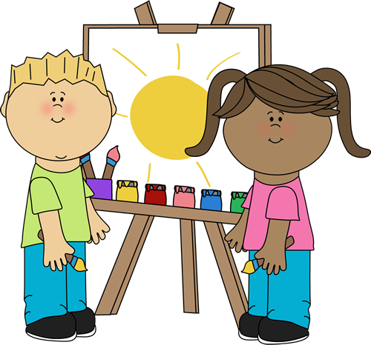

Using technology

Under the sea animals. Mothers’ Day, Pancake day and Easter.

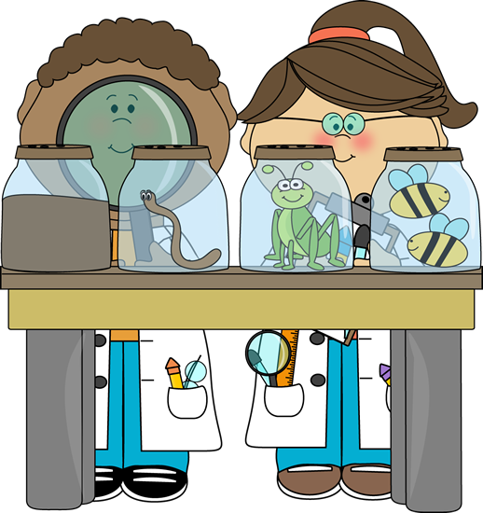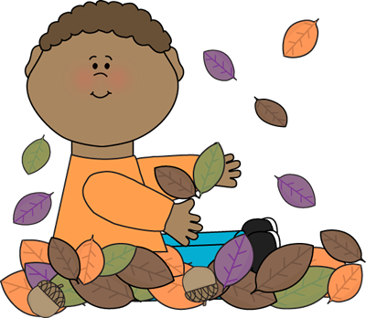

Counting and recognising numbers.

Sorting objects by different criteria.

Continuing patterns.

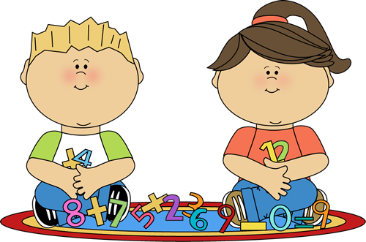

Personal, Social and emotional development.

Expressive Arts

Knowledge and understanding of the world.

Mathematics

Literacy

A Unique + Positive + Enabling = Learning and

child relationships environments development