Home Learning Activities
Class: 3 Week: 3
Monday | Tuesday | Wednesday | Thursday | Friday
English:- “Room on the Broom”  Listen to and watch the story Room on the Broom.  Can you use the cut front cover to rebuild it either onto or next to the original picture?  Room on the Broom - Read by Alan Mandel - YouTube | English:- “Room on the Broom”  Listen to and watch the story Room on the Broom.  Can you complete and find all the witches on the paper. Use a pencil to draw a circle around all the witches. Then can you write or trace the number of how many you found at the bottom of the sheet.  Room on the Broom - Read by Alan Mandel - YouTube | English:  Can you find objects in your house that begin with the letter “i”  https://www.youtube.com/watch?v=qTqfptkcpcY | English:  Can you complete the letter “s” sound sheet? This can be done with or without adult support.  https://www.youtube.com/watch?v=qTqfptkcpcY | English:- “Room on the Broom”  Listen to and watch the story Room on the Broom.  Can you complete the witch comprehension sheet, write or stick in your answers.  Room on the Broom - Read by Alan Mandel - YouTube
Maths:  Can you find objects around your house you can count with? Place your objects on the floor and practice counting to 5, 10, 15 or 20. Can you join in with the actions?  Let's Count to 20 Song For Kids - YouTube | Maths:  Can you practice writing numbers on your formation sheet? | Maths:  Can you match your numbers to the correct pictures in your work packs. | Maths:  Can you practice writing numbers in flour? | Maths:  Can you find objects around your house you can count with? Place your objects on the floor and practice counting to 5, 10, 15 or 20. Can you join in with the actions?  Let's Count to 20 Song For Kids - YouTube
Brain Break  Have a brain break and enjoy dancing to shake you sillies out and other exciting songs.  https://www.youtube.com/watch?v=NwT5oX_mqS0 | Brain Break  Have a brain break and enjoy dancing to shake you sillies out and other exciting songs.  https://www.youtube.com/watch?v=NwT5oX_mqS0 | Brain Break  Have a brain break and enjoy dancing to shake you sillies out and other exciting songs.  https://www.youtube.com/watch?v=NwT5oX_mqS0 | Brain Break  Have a brain break and enjoy dancing to shake you sillies out and other exciting songs.  https://www.youtube.com/watch?v=NwT5oX_mqS0 | Brain Break  Have a brain break and enjoy dancing to shake you sillies out and other exciting songs.  https://www.youtube.com/watch?v=NwT5oX_mqS0
Topic  Can you help to recycle at home by putting some objects in the bin?  https://www.youtube.com/watch?v=AOvcW8l3RzE | Work packs  Have a go at practicing your name using the laminated sheets in your pack | Work packs  Can you write your name or first letter of your name in flour? | Work packs  Choose a fine motor skeet to practice your fine motor skills. | Topic:  We are looking at structures in Art.  Can you use the coloured paper to make your own structure by sticking the paper down at the ends, like in the picture?  Sesame Street: Make Your Own Art Song - YouTube  Colors Song 2 - YouTube  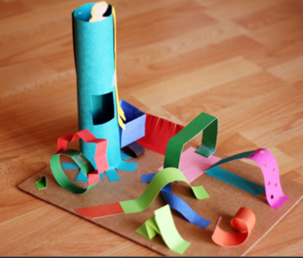

Please use the Home School Learning book to stick in your child’s work and use EFL to take pictures of your child’s work. It will be lovely to see what they are doing at home during this lockdown.

