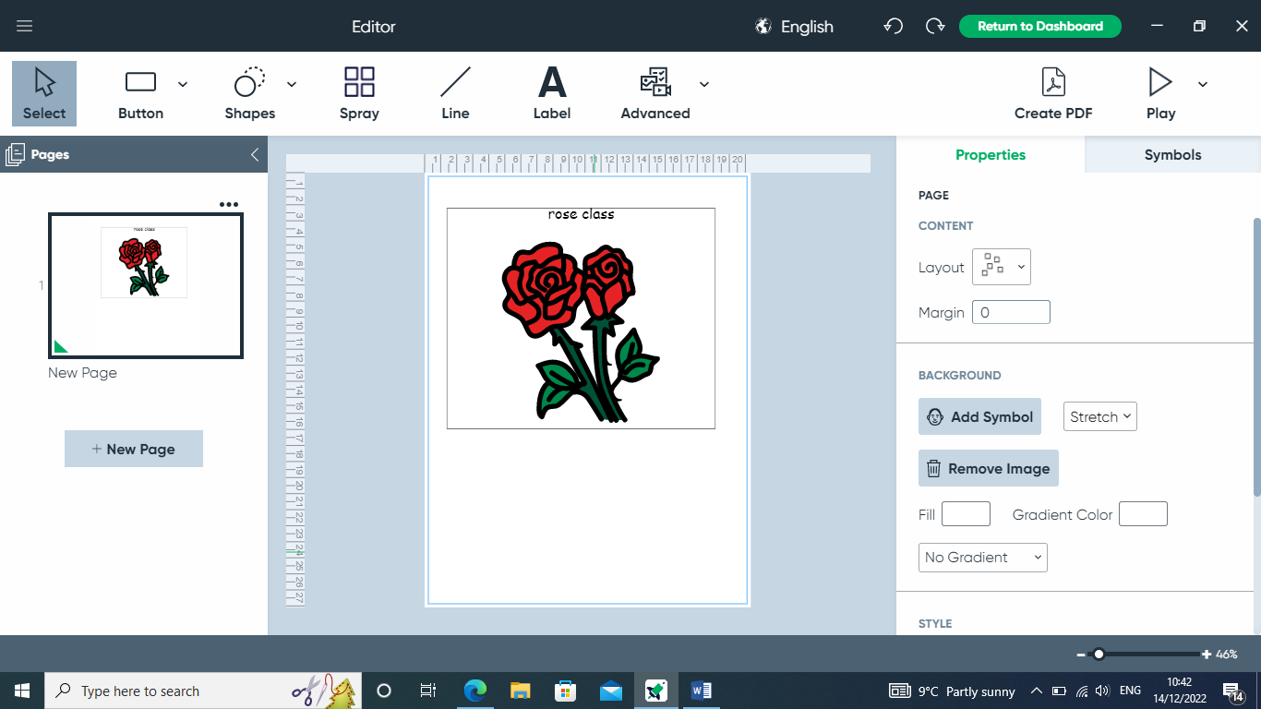

Africa

**Topics**

Number and number recognition

Measuring capacity and length

Money and coins



**Topics**

Stories set in a familiar setting

Animal stories



**Topics**

E-Safety

Multimedia - Art





**Topics**

Animals

Light and colour

Science day – Wonderful Weather!

**Topic**

Safari

Weather in the UK

**Topic**

African Art









**Topic**

Clothes through time

The Great Fire of London

**Topics** –

Spanish food

Spanish Christmas/ Fiestas

**Topics**

Celebrations – Harvest and Christmas

When are the special times for our Communities?

**Topics**

Dance

Gymnastics

Gymn





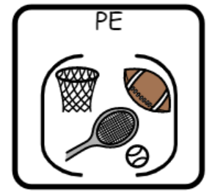

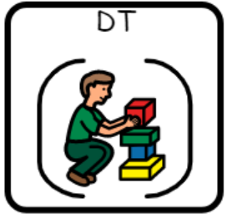

**Topic** –

Textiles – African animal puppets

Mechanisms

**Topic**

Healthy Snacks/5 a day

Foods that make us warm