Home Learning Activities Class P1 15.6.20
Maths (3 days)  https://www.thenational.academy/online-classroom/year-3/maths#subjects  We’re going to try something new in the coming weeks. This link is to a website called the Oak National Academy. Basically it takes you to a series of lessons with actual video lessons with a teacher showing you what to do. This week we’ll be looking at good old fractions.  The screen should look like this…  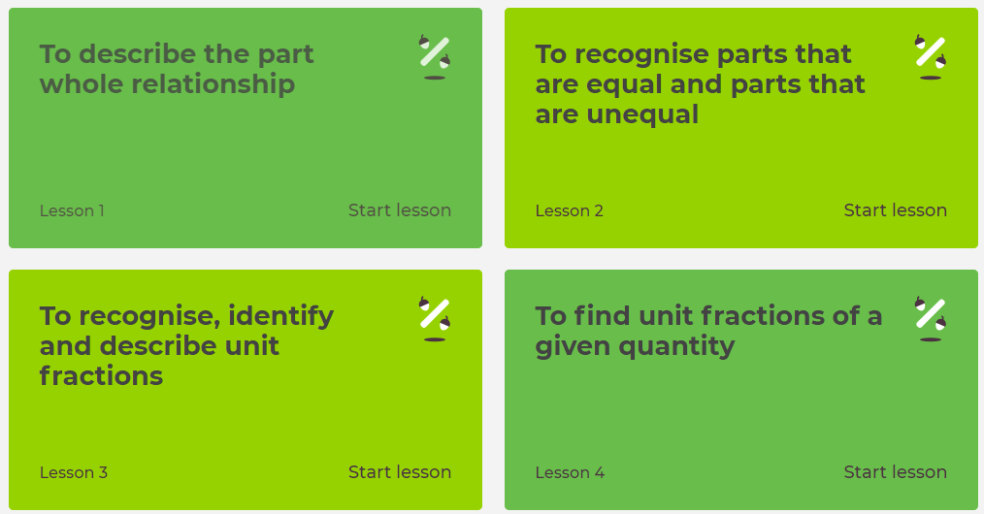  I would like you to try the first 3 lessons- or however far you get. |  |  | Maths  Visit Maths Workout, Maths Whizz or Maths Warm Up and do 1 hour of activities.  (same as last week) | Maths  Find as many different ways as you can to make 180.
English (3 days of work)  https://www.thenational.academy/online-classroom/year-2/english#subjects  This link is the same as the maths (Oak National Academy).  This is a series of reading lessons that are aimed at Year 2 however I feel they would be round about the right level for us. The screen should look like this…  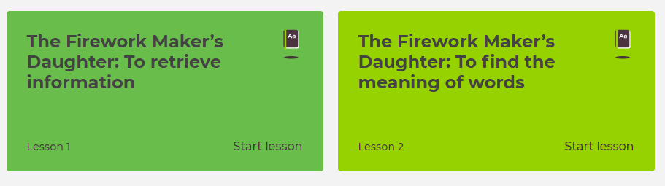  I think that these 2 lessons should take about three days. |  |  | English  Keep a daily diary of your time at home. What did you do today?  (continue from last week- this is an ongoing task) | English  Read some of your book  (continue from last week- ongoing task)
PSHE  (3 days’ worth of work)  https://www.bbc.co.uk/bitesize/topics/z9ssgk7/resources/1  This link will take to to a selection of 10 short videos all about healthy living. I would like you to choose a video, watch it and then create a poster that explains what the video clip was about. You can repeat this with other videos. |  |  | PSHE  Telephone/facetime a friend and have a chat.  (keep as a weekly task) | PSHE  Play a game with someone in your house.  (ongoing task)
PE  https://www.youtube.com/watch?v=rML95Ett5lY&feature=youtu.be  This is another street dance routine video | PE  Really simple one today- how far can you run or walk in 10 mins. Simply see how far you get.  Try it again a few days later- have you improved? | PE  How many of something can you do?  For example, how many keepy ups can you do with a football, how many bounces on a trampoline can you do in a row before getting tired? How many times can you thrown or bounce a ball without dropping it?  *KEEP THIS ACTIVITY FROM LAST WEEK- CAN YOU IMPROVE ON YOUR TOTAL?* | PE  Do a circuit – 20 star jumps, 10 press ups, 20 tuck jumps, 30 second wall sit. Repeat 3 times.  Keep this routine from last time BUT- can you add an extra 10 reps to each exercise?  Or, if you follow a physio programme, do some of the moves from it. | PE  Lift some weights. Use real ones if you have them or if not, use tins! Do exercises you have learned!  Continue from last week- can you do more repetitions than last week?
ART  https://www.thenational.academy/year-2/foundation/to-investigate-the-colours-year-2-wk1-5#slide-2  This is a lovely art lesson with an actual teacher that shows you how to use colour and make art out of natural materials. | Geography  https://www.thenational.academy/year-1/foundation/what-is-a-continent-year-1-wk1-1  I know this is aimed at Year 1, but I think it is about right. Quite an interesting lesson on continents. | History  https://www.thenational.academy/year-2/foundation/how-do-we-know-about-the-shang-dynasty-year-2-wk1-1  This is an interesting lesson on the Shang Dynasty.  There is a video teacher doing it too. | SCIENCE  Great White Sharks!  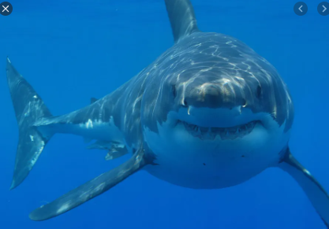  Can you find out as many facts as you can about these amazing creatures! | COMPUTING  Using e-safety rules, stay in touch and chat to your friends for an hour or two each day.  Continue from last week- it is important to maintain good relationships with friends.

****Grown-ups- please remember, do not put yourselves under lots of pressure to try and complete everything on this sheet. Do what you feel you can. If there is one particular area of interest, then do more on that and less on the other bits. I know how busy you all are in these strange times! Stay safe!****

