LO – To add 10 to any number between 0 – 100.
Adding 10

Remember the rule for adding 10 when using a hundred square (move down one space!)
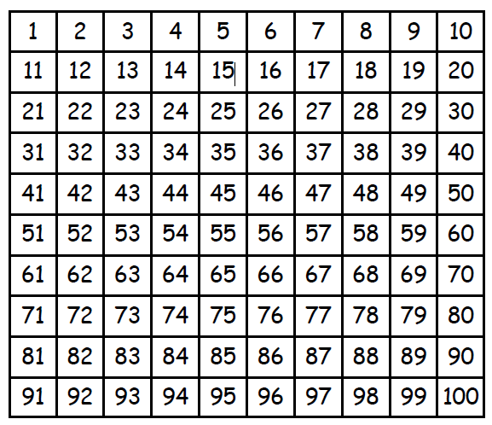
72 + 10 = ____ 6 + 10 = ____
40 + 10 = ____ 47 + 10 = ____
26 + 10 = ____ 51 + 10 = ____
76 + 10 = ____ 39 + 10 = ____
52 + 10 = ____ 89 + 10 = ____

