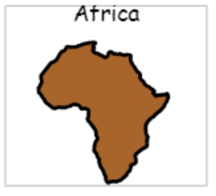

**Topics**

Numbers to 10 and beyond

Missing numbers

Adding

Coin recognition

Using Money

Capacity and Length

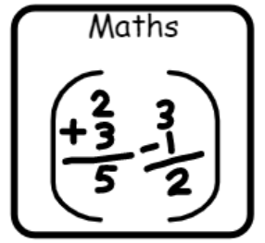

**Topics**

Stories set in familiar settings

Animal stories



**Topics**

Animals around me

Light and colour

**Topics**

E-safety

Multimedia art



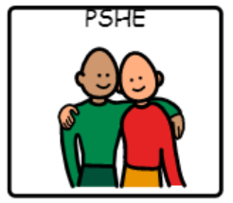



**Topic**

Friendships

**Topic**

African art

**Topic**

Safari









**Topics** –

EL day/Spanish food

Spanish Christmas/Fiestas

**Topic**

Clothes through time

**Topics**

Celebrations - Harvest

Celebrations - Christmas

**Topics**

**OAA**

**Athletics – striking/fielding**





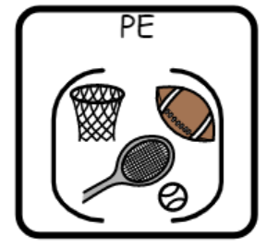

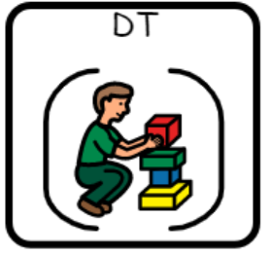

**Topic**

Healthy snacks

**Topic**

Textiles – African puppets