AO2 - Explain and comment on how writers use language and structure to achieve effects and influence readers, using relevant subject terminology to support views.
The Atlantis Hotel
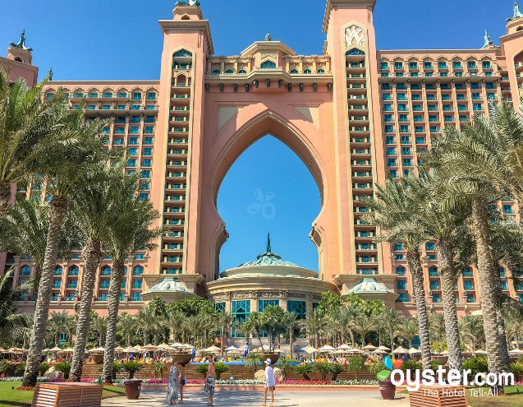
Can you find these persuasive features below:
Rhetorical questions
Tempting descriptions-use of adjectives-majestic,
Exaggeration-dazzling world of imagination, award winning
Alliteration – crazy creatures

Why not visit the Atlantis? a majestic 5 star Dubai hotel situated on the Palm, a man-made island that has captured the world’s imagination with its magnificent scale.
From the moment you arrive, you will be immersed in a dazzling world of imagination, pleasure and luxury of 5 star hotels. The Atlantis beach resort is an aquatic wonderland by the sea offering relaxation and thrills for couples and families alike. From the hotel architecture to the award-winning restaurants and must-visit aquatic attractions, this is one of Dubai’s luxury resorts that never ceases to amaze the senses.
The best day out in the UAE is waiting for you at Aquaventure Waterpark this summer! From your very first step through the ticketing plaza gate you will be spoilt for choice on the exciting adventures you can experience throughout the day! Speed down some of the most thrilling rides you will ever come across, navigate your way through whirlpools and waves whilst taking a journey along the rapids and remember, whether you’re on an inner tube or your bare skin, you’re at the mercy of gravity as you make your way down – and sometimes up – the slippery slopes!
Dolphin Bay in Atlantis is one of the most sophisticated dolphin habitats in the world. Here you have the opportunity to swim with world famous dolphins in Dubai; choose from a range of dolphin experiences suitable for all ages and swimming abilities. Interactions range from standing in shallow water to swimming or scuba diving alongside these charismatic creatures. Whether you’re a hotel guest or visiting for the day, Dolphin Bay in Dubai offers an unforgettable experience.
What are you waiting for? book now before somebody else does.

