SCERTS (Covers DT, RE, Art, Geography and History)

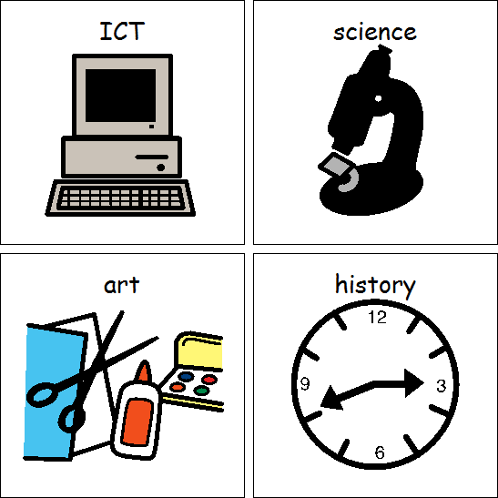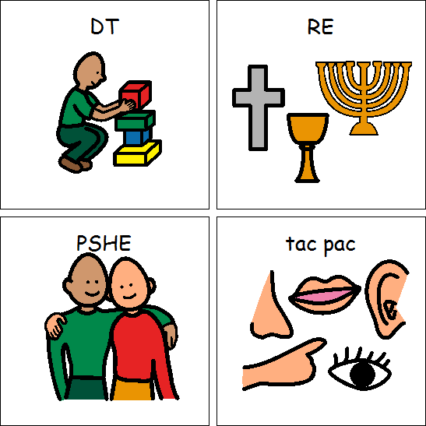 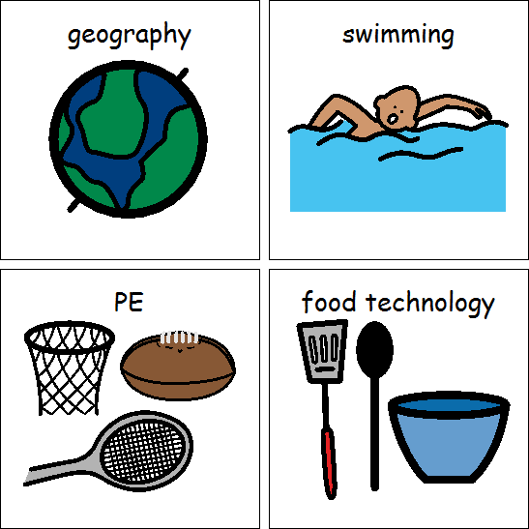 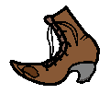 AFRICA

Clothes through time – History

Safari- Geography

Celebrations (Harvest and Christmas)- RE

African art- Art

Healthy snacks- DT

Maths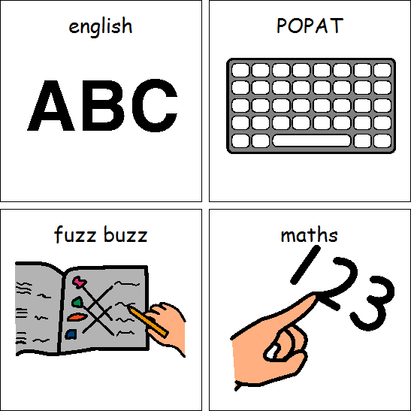

Dance

Gymnastics

PE



Topics

*Taught through Spanish themed afternoons*

Spanish food

Spanish christmas

Topics

*Taught cross-curricular*

E-Safety and multimedia art

Topics

Number

Money

Shape and measures

Topics

Stories set in a familiar setting

Instructions

POPAT

Letters and sounds

Class 6B Autumn 2019

Languages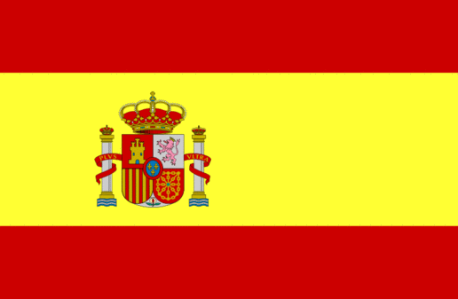

Computing



English



Animals around me

Why does it light up?

Science

