Badger Class Autumn Term 2022



Badger class staff.

Ms K.White

Ms J.Forrest

Miss N.Vance

**Topics**

**Autumn 1 -**

Place Value and Number. Solve practical problems involving place value

**Autumn 2 -** Add and subtract numbers using a formal written method and mental. Solve real life problems.

**Topics**

**Autumn 1**

Stories by Roald Dahl.

**Autumn 2**

Explanations.

**Ongoing** - Spelling and Phonics, Guided Reading, Guided Writing, Handwriting.

Speech and language work.

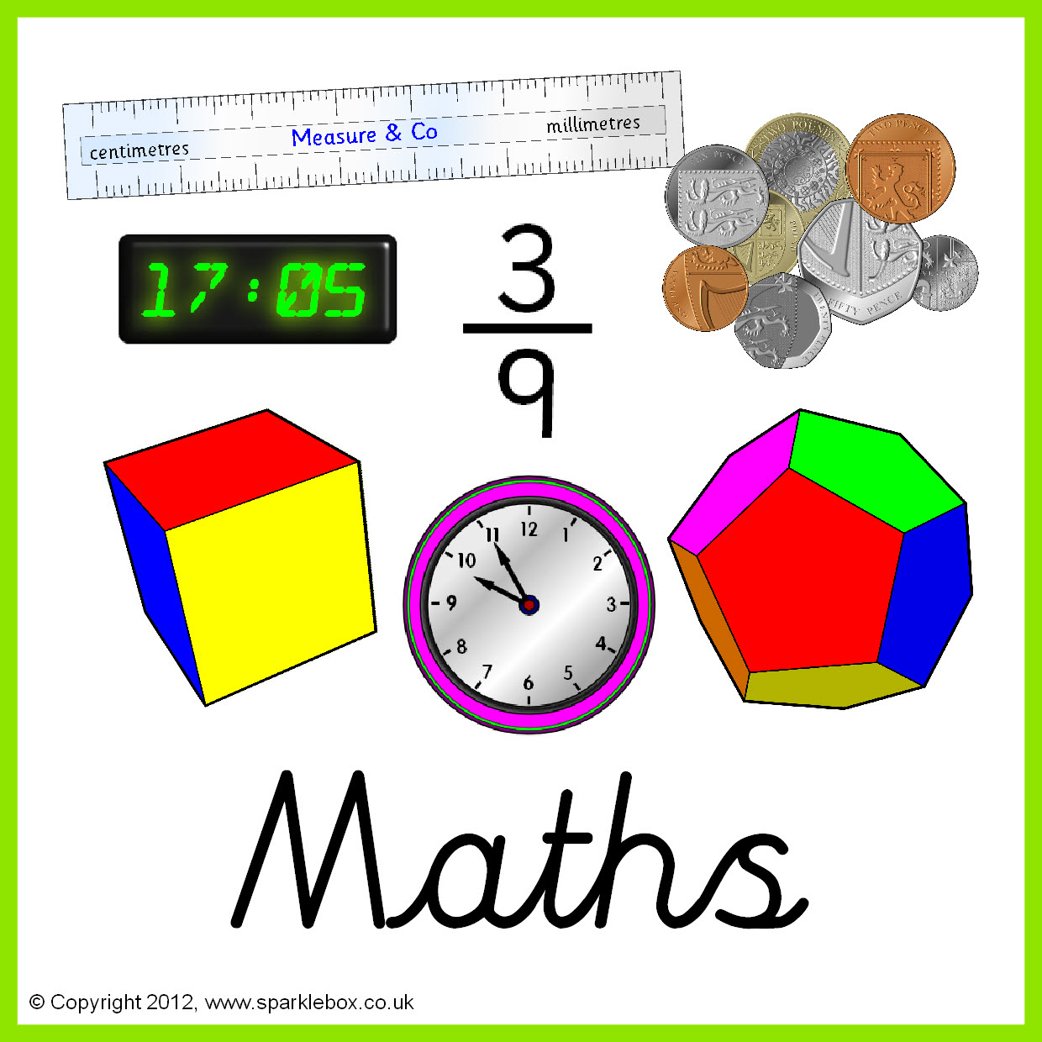

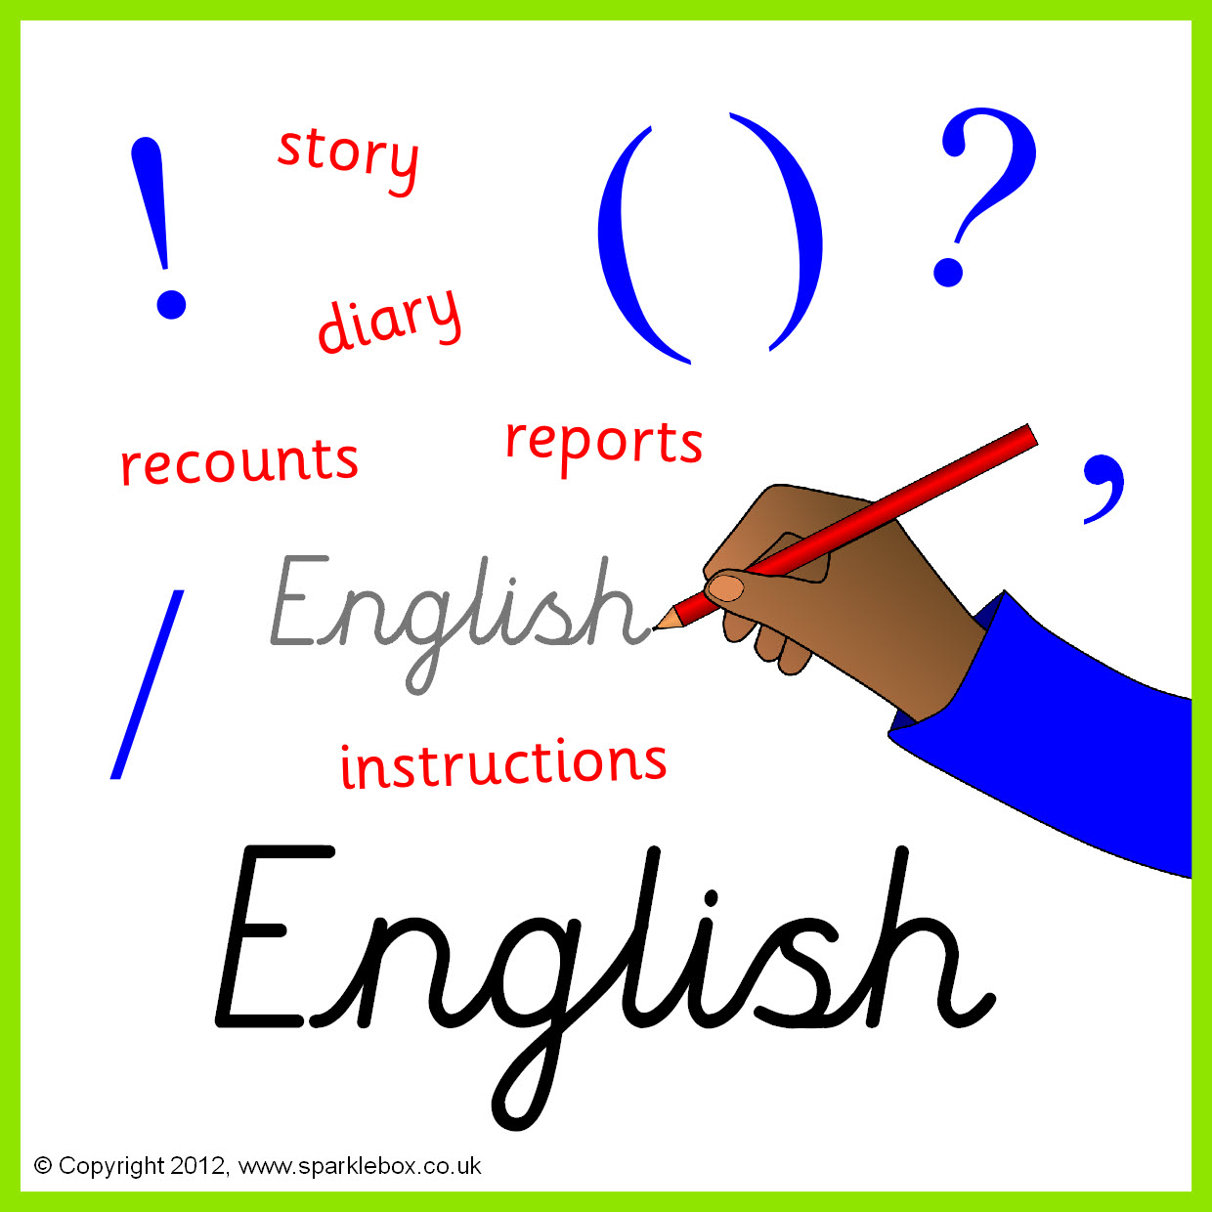

**Topics**

**Autumn 1** – Forces - Resistance, gravity and friction.

**Autumn 2** - Properties and changes of materials- Solids, liquids, gases.

Properties and changes of materials.

**Topics**

**Autumn 1** - E-safety.

**Autumn 2** - Algorithms & programming.





**Topics –**

**Autumn 1** - Introduction to formal elements of art.

**Autumn 2** - Weird and Wonderful.

Weird and Wonderful

**Topics** -

Geography of Brazil.







**Topics -**

**Autumn 1** - Body parts – labelling. Numbers to 20.

**Autumn 2** – Celebrations: Spanish Christmas and fiestas. Spanish greetings.

**Topic** -

Roman Invasion of Britain.



**Topics -**

**Autumn 1** – Goal ball.

**Autumn 2** – Circuit training.

**Topics**

**Autumn 1** – Various Religions- Where do we Belong?

**Autumn 2** – Christianity and Judaism.





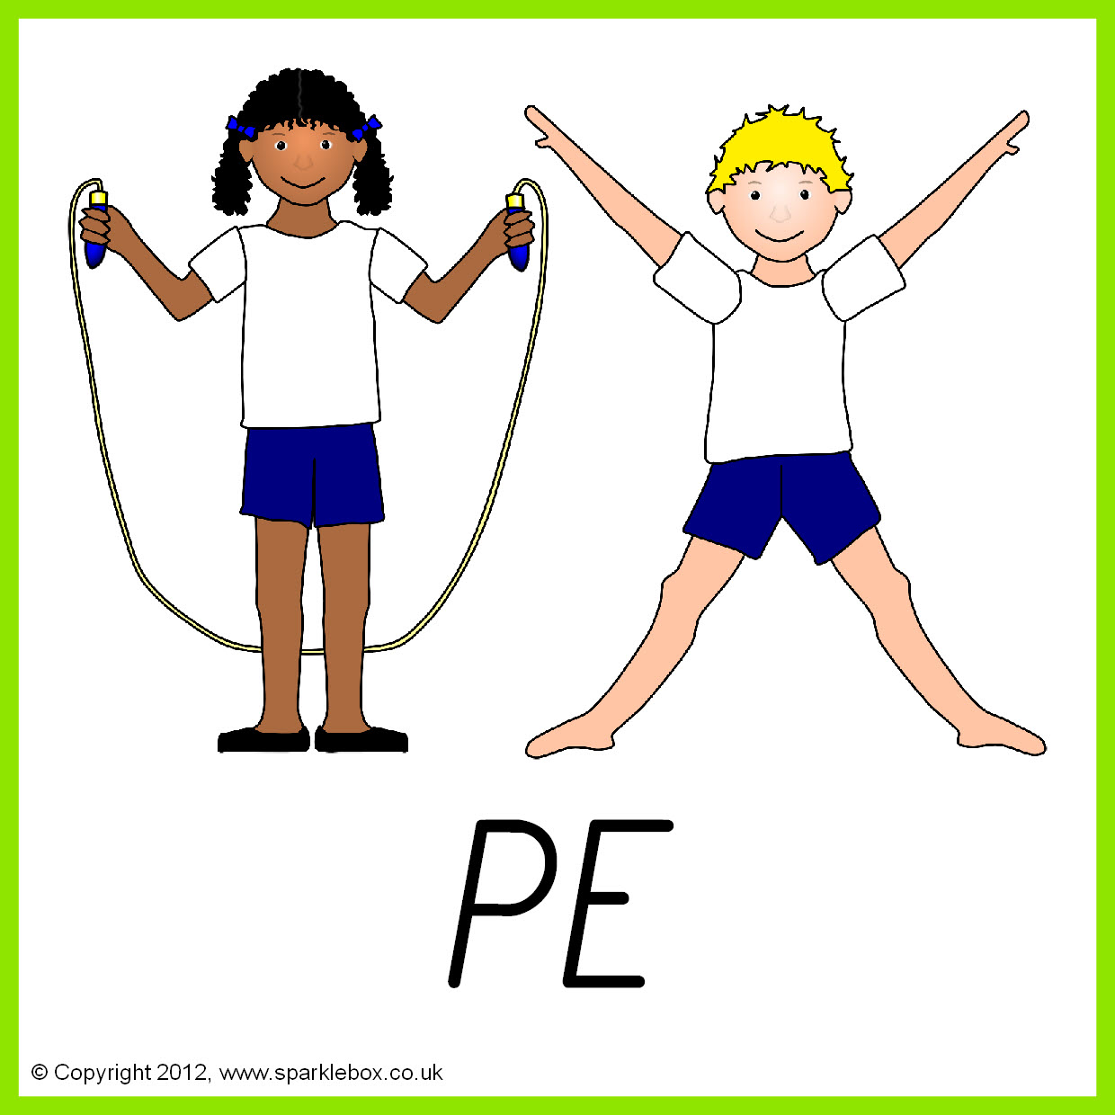

**Topics -**

**Autumn 1** – Inventions and inventors.

**Autumn 2** – Basic food hygiene.

**Topics**

**Autumn 1** – Talking about Emotions.

**Autumn 2** – Keeping Safe (First Aid, Road Safety etc.

.

