LO –To predict what a character is like.

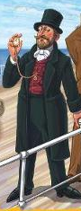

Phileas Fogg