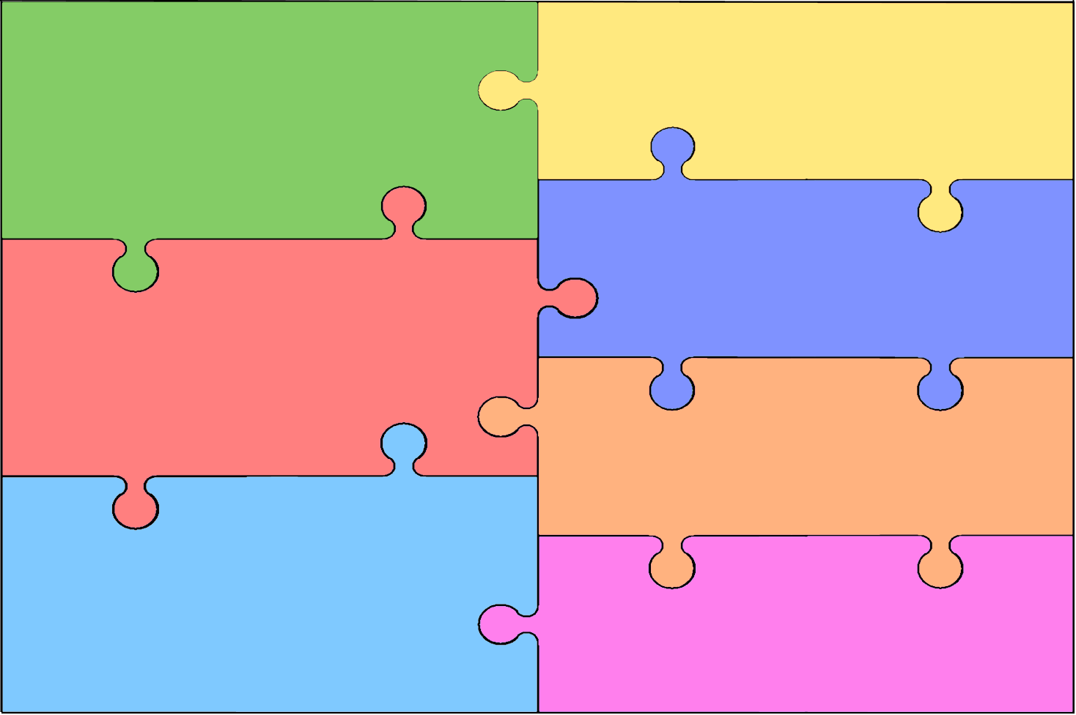
Curriculum Overview for Early Years Foundation Stage
Personal, Social & Emotional Development  - Building confidence to choose activities  - Build awareness of needing help, and how to ask  - Confidence to speak to familiar people  - Working as part of a group, following rules where appropriate  - Forming positive relationships with peers and adults  - Playing co-operatively, taking turns | Literacy  - Learning letters and sounds  - Encountering stories  - Discuss what has been read  - Development of mark making and writing
Mathematics
- numbers up to 20
- Beginning to count
- Begin to recognise and describe simple patterns
- Use everyday language to talk about size, position, time , etc.
- Investigating shapes
Communication & Language

- Listening attentively, including while completing tasks
- Listening to stories and responding to them
- Following instructions to carry out activities
- Speaking and communicating
- Understanding simple words and sentences
Understand the World
- Events in their lives and their families
- People in different communities
- Similarities and differences between objects
- Plants and animals
- Technology
Physical Development

- Developing control and coordination of movement
- Handling equipment and tools, including for writing
- Learning about healthy diet and exercise
- Managing their own hygiene and personal needs
Expressive Arts & Design

- Experiment with songs, music and dance
- Use a range of artistic materials, tools and techniques
- Work imaginatively
- Engage in art, music, role-play, dance and stories

