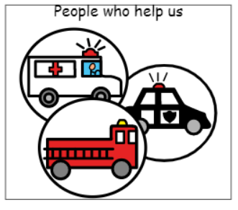

**Topics**

Addition and subtraction

Measuring Mass

Time

2D shapes and properties

Making pictures using shapes

Repeating patterns

Positions

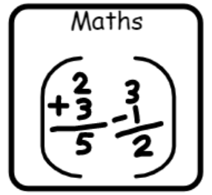

**Topics**

Stories through role play

Posters

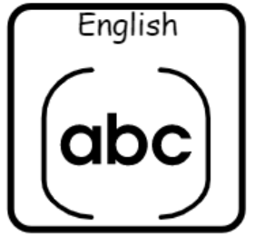

**Topics**

Changing materials

Electricity

**Topics**

Sound and music

Programming and algorithms

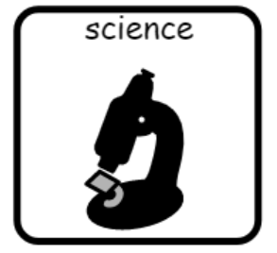

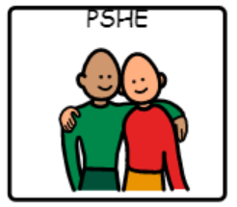

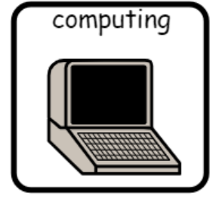

**Topic**

Friendships

**Topic**

African art

**Topic**

Weather in the UK

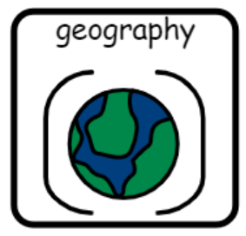

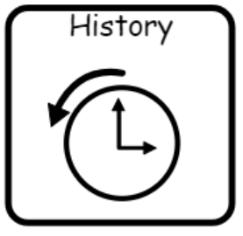

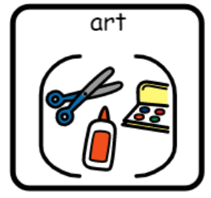



**Topics** –

Numbers to 5

All about Spain (weather, travel)

**Topic**

The great fire of London

**Topics**

Stories from religion

The Easter story

**Topics**

Gymnastics

Invasion games

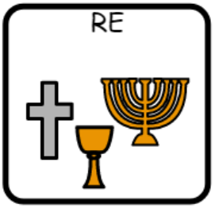

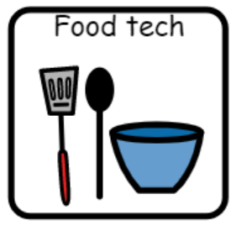

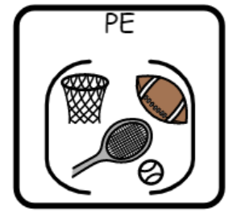

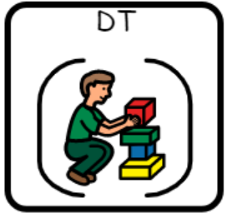

**Topic**

Foods that make us warm

**Topic**

Mechanisms – emergency vehicles