Home Learning Activities
Maths  Get someone at home to test you on your 5 and6 times tables | Maths  Design a dream bedroom room- how much would it cost? Where would you get all the things for it from? | Maths  Visit Maths Workout, Maths Whizz or Maths Warm Up and do 1 hour of activities.  (same as last week) | Maths  100 is the answer- what could be the question? Think of as many different questions as possible. E.g I have 26 seeds and plant 74 more, how many seeds have I planted? | Maths  Find as many different ways as you can to make 39.
English  Keep a daily diary of your time at home. What did you do today?  (continue from last week- this is an ongoing task) | English  Write a story about a terrible day: what would it be like? | English  Read some of your book  (continue from last week- ongoing task) | English  Watch this video (it is a tiny bit creepy!)  https://www.youtube.com/watch?v=5fbZTnZDvPA  Do you understand what happened in the film?  What would you have done to escape? | English  Write a review of your favourite book or film
PSHE  Tidy your room or any other room for your parents. | PSHE  Make a list of all the things you want to do when quarantine is over. | PSHE  Either by writing or by filming yourself on a phone or i-pad, talk about the positive qualities of people in your family | PSHE  Telephone/facetime a friend and have a chat.  (keep as a weekly task) | PSHE  Play a game with someone in your house.  (ongoing task)
PE  Try the Joe Wicks PE lesson | PE  Go for a walk/run/walk the dog. Can you find a different route to one you have tried before? | PE  Do a circuit – 20 star jumps, 10 press ups, 20 tuck jumps, 30 second wall sit. Repeat 3 times.  Keep this routine from last time BUT- can you add an extra 10 reps to each exercise?  Or, if you follow a physio programme, do some of the moves from it. | PE  See if you can keep up with this yoga for kids video? This week the theme is Star Wars!  https://www.youtube.com/watch?v=coC0eUSm-pc | PE  Lift some weights. Use real ones if you have them or if not, use tins! Do exercises you have learned!  Continue from last week- can you do more repetitions than last week?
ART  Make a collage from old bits of paper or magazines | FOOD TECH  Design and make a delicious smoothie! | DT  Using some paper/cardboard- design a birthday or greeting card for someone  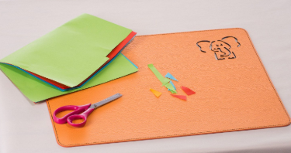 | SCIENCE  Choose a subject to research on the BBC bitesize website  Same activity as last week- but choose a different subject | COMPUTING  Using e-safety rules, stay in touch and chat to your friends for an hour or two each day.  Continue from last week- it is important to maintain good relationships with friends.
Class: P1 Week: 4 Week Beg: 20th April

